turkısh aırlınes lufthansa aırlınes

Marketing 301

SABANCI UNIVERSITY   
GROUP 9

B. Neslihan Tülük

H. Berk Tahtacı

H. Sena Şişman

Eylül Tekeş

Furkan Reha Tutaş

REPORT 1

**LATEST NEWS ON TWO BRANDS AND THEIR EFFECTS ON STOCK PRICE**

**Turkish Airlines**

According to Hurriyet, Turkish Airlines and Turkish Aerospace Industries havesigned a protocol to increase their level of partnership on 15 February 2018. They’ll mostly cooperate in civil and military aircraft productions and technical issues. Additionally, the CEOs of the companies, state that this cooperation will help the sector to be developed and enlarged (Hurriyet, 2018).

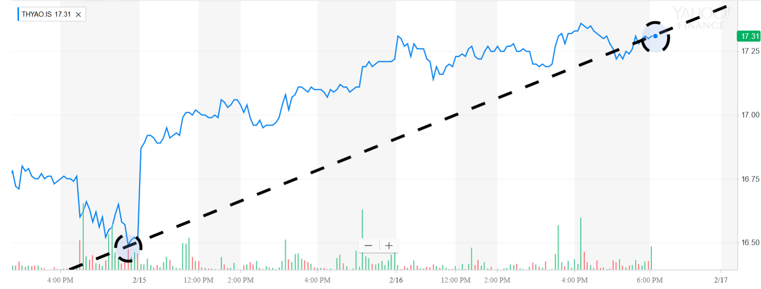**The Effect on Stock Price:**

[Screenshot of a graph from Yahoo Finance]

It can be observed that there is a trend line which is increasing after the protocol agreement. As a result, there is a positive correlation between the sign of protocol and the stock price of THY.

**Lufthansa**

According to Marketing Interactive, the logo of Lufthansa has been redesigned. The old logo had served approximately for a century. After 7 February 2018, the new logo will start to be used. The company claims that this change creates a perception that the company is different and special from the other companies (Marketing Interactive, 2018).

**The Effect on Stock Price:**

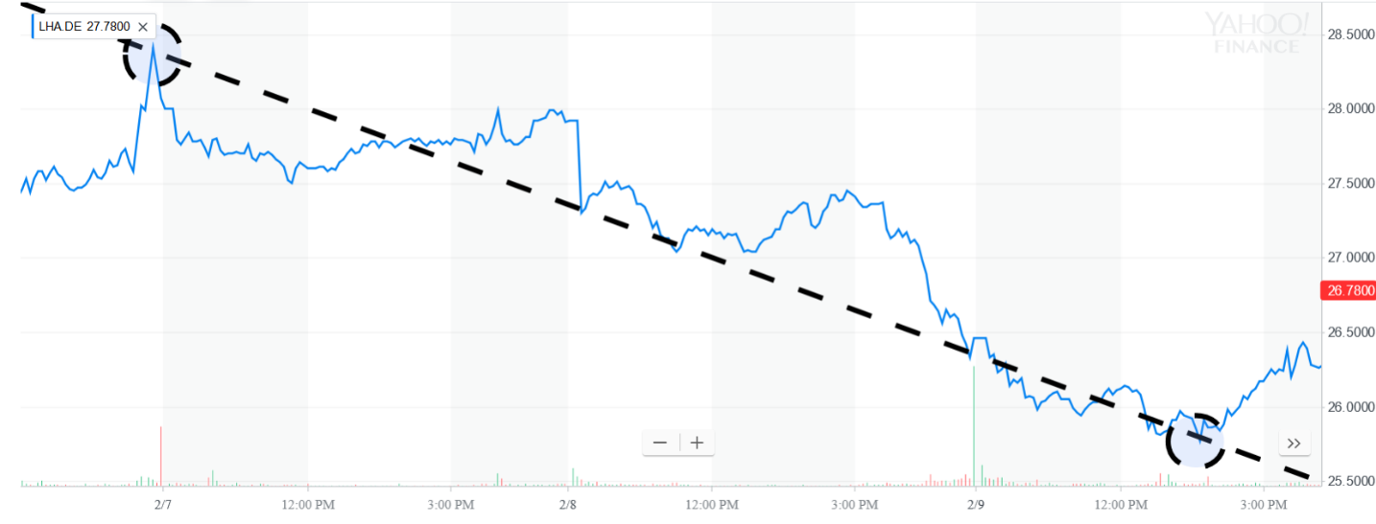

[Screenshot of a graph from Yahoo Finance]

It can be observed that there is a trend line which is decreasing after the redesigning of the logo. As a result, there is a negative correlation between the redesigning and the stock price of Lufthansa.

**MARKETING EXPENSES AND CHANGES OVER YEARS**

**Turkish Airlines**

The following data from Yahoo Finance shows the Operating expenses of THY. The most related part to the marketing expenses is the data Selling General and Administrative. It can be assumed that the 70% of the Selling General and Administrative is approximately the marketing expenses by the company.

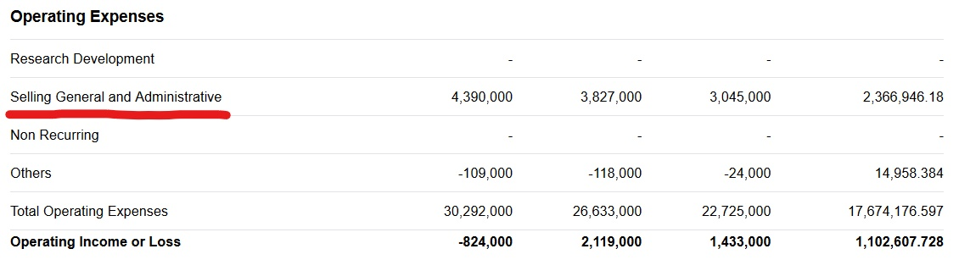

[Screenshot of the data from Yahoo Finance]

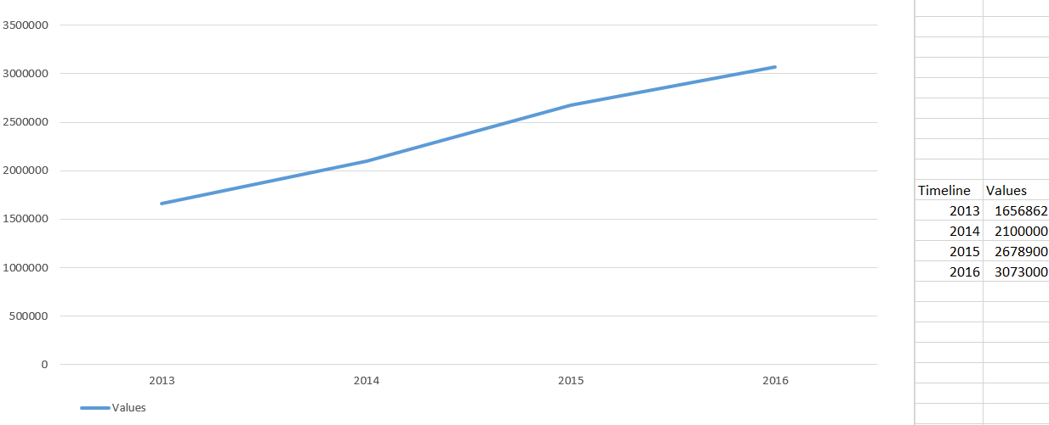

[The chart of Marketing expenses over the years]

The chart shows that approximate marketing expenses of THY has an increasing trend line between the years 2013 and 2016. Additionally, the slope of the trend line is same over the years. This means that THY has a strategy which gives importance to the marketing. For that reason, they increase marketing expenses over the years with similar increase rate (Yahoo Finance, 2018).

**Lufthansa**

The following data from Yahoo Finance shows the Operating expenses of Lufthansa. The most related part to the marketing expenses is the data Selling General and Administrative. It can be assumed that the 70% of the Selling General and Administrative is approximately the marketing expenses by the company.

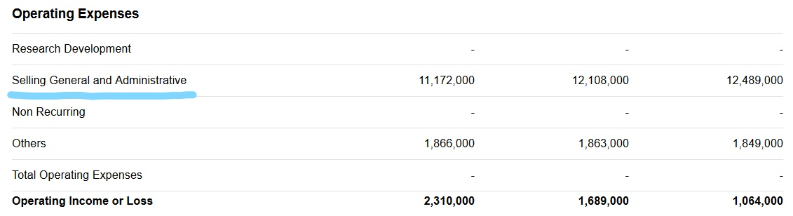

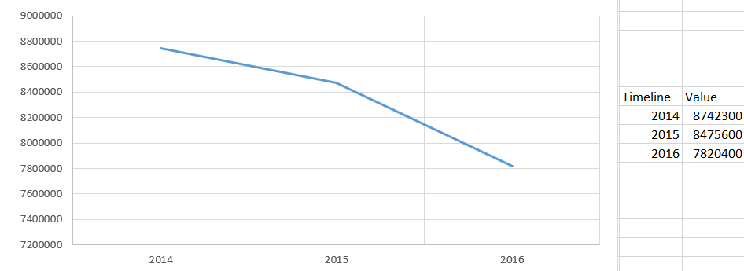[Screenshot of the data from Yahoo Finance]

[The chart of Marketing expenses over the years]

The chart shows that approximate marketing expenses of Lufthansa has a decreasing trend line between the years 2014 and 2016. However, this is a small decrease rate, relatively to the increase rate of marketing expenses of THY. Although, there is decrease over the marketing expenses, it can be claimed that they nearly spend the same amount money for marketing between 2014 and 2016 with small decrease rate (Yahoo Finance, 2018).

**TURKISH AIRLINES**

**Strength:** Services and customer satisfaction are internal environment because they depend on the company itself. According to the Turkish Airlines 2015 annual report, dishes served on airplanes were diversified and chefs started to prepare meals (THY Annual Report 2015, p.40). At the same time, some aircraft has wireless and some of the next generation aircraft began broadcasting (THY Annual Report 2015, p.41). These innovations have played a role in the selection of Turkish Airlines for the flight of passengers (THY Annual Report 2015, p.41). As a proof, Haberturk states that THY has 85% success of consumer satisfaction according to Which? (Haberturk, 2016).

**WEAKNESS**

**THREAT**

**Geographical location.**

**Expensive ticket prices.**

**STRENGTH**

**Terrorist organizations and wars.**

**Services and customer satisfaction.**

**OPPORTUNITY**

**Weakness:** Expensive ticket prices are internal environment because they are a part of the marketing strategy of the company. High ticket prices appeal to a certain group of people with a specific financial income. This situation decreases the number of customers by narrowing the spectrum of customers.

**Opportunity:** Geographical location is external environment because it depends on the location of Turkey. World passenger traffic has risen 5.9% in 2014 and 5.6% in the last decade (Karahan, p.20). Our country is well above this value and our civil aviation has begun to take a bigger share in the transportation of global citizens (Karahan p.20). Turkey, with its geographical position in the airline transport has an important place and shows the importance of constantly increasing air traffic. Due to its geographical location in the airline transportation, Turkey has an important place in sector.

**Threat:**

Terrorism and wars cause confusion in certain areas, which leads to a decrease in travel to those zones. Also, confidence in airplanes that land in that area is reduced. This leads to a decrease in the number of flights and the company to do less work. Turkish Airlines has seen a 50% drop in its domestic / international traffic, and the work of some employees has been terminated accordingly (Kişioğlu, 2014).

**LUFTHANSA**

**THREAT**

**OPPORTUNITY**

**STRENGTH**

**WEAKNESS**

**Poor labor relations.**

**Coverage in Europe.**

**Increased costs.**

**Increase in foreign travel.**

**Strength:** Coverage depends on the company marketing strategies therefore, it is an internal environment. Lufthansa has many central offices in Europe. Lufthansa is also part of Star Alliance which also includes Thai Airways International, United Airlines, Air Canada and Scandinavian Airlines (Bhasin, 2017). Lufthansa also provides full coverage to the area. This situation also triggers customers to prefer Lufthansa on flights in many different countries.

**Weakness:** Poor labor relations can be improved; therefore, it is internal environment. The company has had bad times because of problems with its employees. These problems even caused strikes. Lufthansa had a big strike at 2012 (BBC, 2012). That strike effected flight of 43 thousand passengers (Milliyet, 2012). The strikes that company has experienced in the past may cause the passengers to be hesitant to receive tickets.

**Opportunity:** Increase in foreign travel is external environment because it depends on change in consumer profile over years. As there are numerous businesses open to various parts of the world, the international travel opportunity has increased considerably (Bhasin, 2017). The increase in the number of places to go with a single airline company made Lufthansa the top choice as a good choice.

**Threat:** Increased cost depends on external products; therefore, it is external environment. 24.4% of the monthly deviations between oil prices and Lufthansa are eliminated (Eyüboğlu, K & Eyüboğlu S, 2016). Because of the maintenance and labor costs increase, the service price also increases. This price increase can lead some customers to more affordable competitors, leading to customer loss.

**GROWTH STRATEGIES**

**Turkish Airlines**

Turkish Airlines is one of the fastest growing and successful airline in the world. The company maintains their growing by practicing some strategies. Market development and market penetration are one of these strategies which Turkish Airlines use.

As market development Turkish airlines aims that adding new destinations and going different places is an important growing strategy. According to Kemal Kizilay, Turkish Airlines had started their first direct flights from Istanbul to Miami at 25th October 2015 and this leads to an increase in the number of passengers by %65 in Istanbul-Miami line (Vatan, 2018).

Also, they want to be an international player, so they joined the Star Alliance in 2008 (Lida Mantzavinou, 2011). This partnership helped them to advertise their name and it is a good movement for market development.

They use market penetration while they are growing. They make sponsorships with giant sport clubs such as Barcelona and celebrity endorsements with Kobe Bryant etc. These acts helped the company to achieve higher brand recognition around the globe.

**Lufthansa Airlines**

Lufthansa Airlines is the leading airline group in Europe. They use strategies while they are playing number one in Europe.

They pay attention to product development. According to Lufthansa Group, they are replacing older aircrafts with more recent models with higher seating capacities and greater fuel efficiency without increasing the total number of aircrafts (Annual Report,2016).

In addition, they add new destinations for developing their market. According to Lufthansa Group, they make new additions to their destinations such as Heraklion and Seville to Lufthansa’s flight Schedule (2015).

**THE RESPONSIBILITY PROJECTS**

**Turkish Airlines**

Turkish Airlines pay attention to making some social responsibilities not just in Turkey but also all around the world.

Their motto is ‘caring all nationalities’. They try to put all nationalities under one umbrella (THY, 2018).

**SOCIAL RESPONSIBILITY PROJECTS:**

**1 million saplings ,1 million smiling children:** Turkish Airlines plants saplings for every infant passenger that flies with them. In 2014, Turkish Airlines established memorial forests in 19 cities. In 2015, they set their target of planting add up to of one million saplings over it provinces (THY, 2018).

**School visits from the Turkish airlines flight team:** Volunteers from cabin crew and cockpit crew made visits to schools under the name of the Turkish Airlines flight team. They talked with children about topics such as aviation, aerodynamics, aircraft speed and the wonders of the first flight. They also gave children a present like Turkish timber aircraft models, kites and other similar gifts (THY, 2018).

**Kite festival:** With the help of the volunteers, Turkish Airlines organized a kite festival for almost 200 orphans in 2014. They moreover made space for instructive exercises at the festival which was joined by Turkish and Syrian orphans living in social administrations ‘affection homes’ and other orphanages financed by various organizations (THY, 2018).

**The social responsibility project from THY in Japan:** In 2011, there was a big earthquake and a tsunami occurred in Japan. Japanese people suffered from these natural disasters. After this sad event, Turkish Airlines supported the development of the region and tried the help of the citizens. Also, they put their logos on the Sanriku Railways at the state of the Iwate. With this movement, they want to give a message to Japanese people that “we are here for you.” Also, the advertising revenue of this project donated to that damaged region and its people (Taskiran, 2015).

**Lufthansa Airlines**

The Lufthansa Group has more than 128,000 representatives around the world. With a wide range of options for proceeding education and adaptable working hours, they have choices for their professional improvement and keeping up an expert knowledge, and for making career and family consistent. The highly motivated and qualified team of employees from 144 diverse nations is thus as well prepared as possible for the future’s challenges. Working at Lufthansa Group has numerous features. But the focus is always on people (Lufthansa, 2018).

**SOCIAL RESPONSIBILITY PROJECTS:**

1. The non-for-profit organization now covers around 30 projects from around the World under one umbrella, which intended to help young people to access education and to enable them to lead self-determined lives in accordance with motto ‘Closer to the World. Closer to its people’ (Lufthansa, 2018).
2. In the past few years,140 projects have been supported. The content of the projects corresponds with the strict standards of the UN Convention on the Rights of the Child and the sustainable goals of the UN for 2030 (Lufthansa, 2018).
3. They constituted the system of fuel saving. By the way, they support the ecological system. They try to help to stop the global warming and protect the climate (Lufthansa, 2018).

In brief, the Lufthansa Group cares about all nationalities and the environment. In fact, their motto gives us a clue about it. There is no racism, they don’t make any discrimination. You can be black or white, it is not a problem for them. They focused on humanity. So, people make their decisions according to their way of thinking. At the end they gain success.

**HALO AWARDS**

Both Turkish Airlines and Lufthansa Airlines do not have any halo awards.

If we need to give an example it can be the Canada and West-Jet Airlines. They cooperated with the “Make a Wish” organization and made help to the sick children. They had a fight for making better treatments for their medical conditions. They made a partnership together and made a video for these sick children. Their aim is to announce the necessities of these children to the public by publishing this video. According to Engage for Good, the video garnered 4.2 million total views on Facebook and YouTube—1.2 million on Facebook and 302,000 in the first 24 hours (2017). At the end, the impressions about the make a wish organization increased and a lot of people had an information about them.

REPORT 2

Lufthansa Airlines has two main target markets which are leisure market and business market.

While making our survey, we will focus on the business market. For business market, we can assume that the age interval is between 35-55, the education level is at least graduate, and the income level is higher than $50000. Euro-stats claims that there are 26 million active enterprises with some 144 million persons employed in Europe (Euro-stats, 2017). From this data, it can be predicted that there are approximately 500.000 business men/women in Turkey who are suitable to the business market definition. According to Survey System, there should be 384 people to sample 500.000 business people with confidence level %95 and confidence interval 5 (Survey System). For example, if the survey indicates that %70 of the business market thinks that the change of a logo is influential, which means that the company can rely on the result with %95 confidence level and 5 confidence intervals. As a result, the survey indicates that (with a high possibility (%95), and a less mean squarer error (5)) approximately %65-75 of business market would choose “Yes” as an answer.

In the focus group we will concentrate on both leisure and business market. We will choose 8 people, 4 of them is from business market and the other half is from leisure market. We will ask them 5 questions which are slightly discussible.

To decide whether to change the logo of the company is influential or not, it is better to use surveys to understand the reaction and ideas of the consumers. Moreover, to decide the shape or the color of the logo, it is more effective to conduct experiments to observe the effects of redesign over the costumers. Additionally, if the aim is to understand the reasons behind the logo redesign it is better to create focus group discussions.

**THE SURVEY**

1. **The logo of a company is important for marketing.**

A) Strongly Disagree

B) Disagree

C) Weakly Disagree

D) Neutral

E) Weakly Agree

F) Agree

G) Strongly Agree

1. **The logo of a company should conform with today’s standards.**

A) Strongly Disagree

B) Disagree

C) Weakly Disagree

D) Neutral

E) Weakly Agree

F) Agree

G) Strongly Agree

**3- Please match the logos and the companies.**

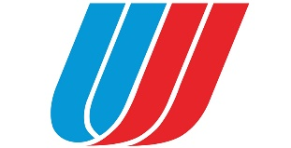

1. United Airlines
2. Emirates Airlines
3. ****Turkish Airlines
4. Qatar Airlines

**4- Choose 2 colors to create a logo.**

1. Black-Red
2. Dark Blue-White
3. Light Green- Yellow
4. Pink-Grey
5. Other. Please Specify.

**5- Redesigning of a logo is influential.**

1. Yes
2. No

**FOCUS GROUP QUESTIONS**

1. **Why do companies/brands change their logo’s?**
2. **What is the name of the company which comes to your mind when you see the word “logo”? Please specify.**
3. **Does a logo reflect the time-period when they are designed, and can you realize which one is old and which one is new?**
4. **How can the change of a logo affect the brand?**
5. **Can a logo affect your decision while you are buying a plane ticket? Give an example and discuss.**

REPORT 3

**PART 1**

As a team, we choose the fill out two surveys which are related to the ‘spending habits’:

The first one is **The Experiential Buying Tendency Scale** which is developed by Dr. Ryan Howell at San Francisco State University. The survey indicates that whether a consumer is most likely to spend his or her money on material things or life experiences. Moreover, they claim consumers which spend their money on life experiences are relatively happier than the ones who spend their money on material things. As a conclusion, the survey shows that people who are willing to gain new experiences from the life, tend to spend more on life experiences, on the other hand people who has less tendency to face with new experiences in life, spend more money on material things (Beyond the Purchase, 2018).

The second one is **the Motivations for Experiential Buying Scale** which is developed by Garg Zhang. There are three main reasons to buy life experiences intrinsic, extrinsic and without any reason. The survey basically indicates that which reason a consumer spend his/her money on life experience. Moreover, only the ones who spend their money on life experience with intrinsic reasons are relatively happier than the others. As a conclusion, the survey indicates the reason behind the purchase of the life experiences (Beyond the Purchase, 2018).

Our brands are Turkish Airlines and Lufthansa. Their main target is people who regularly use the airplane. As it can be predicted, the ones who spend more money on life experience will regularly buy more tickets. In that manner, the first survey can be used to determine the people who spend more money on and give more importance to life experiences. Additionally, when they find their target market as the ones who spend more money on life experiences, the brands should distinguish the reasons behind the choices. At that point, the second survey can indicate the reasons behind the choices. As a result, the brands can develop different marketing strategies to distinctly reach the people who give more importance to new life experiences with different reasons. For example, THY made a YouTube advertisement which is called “Widen Your World” and they add this feature to their website to especially reach the people who give more importance to new life 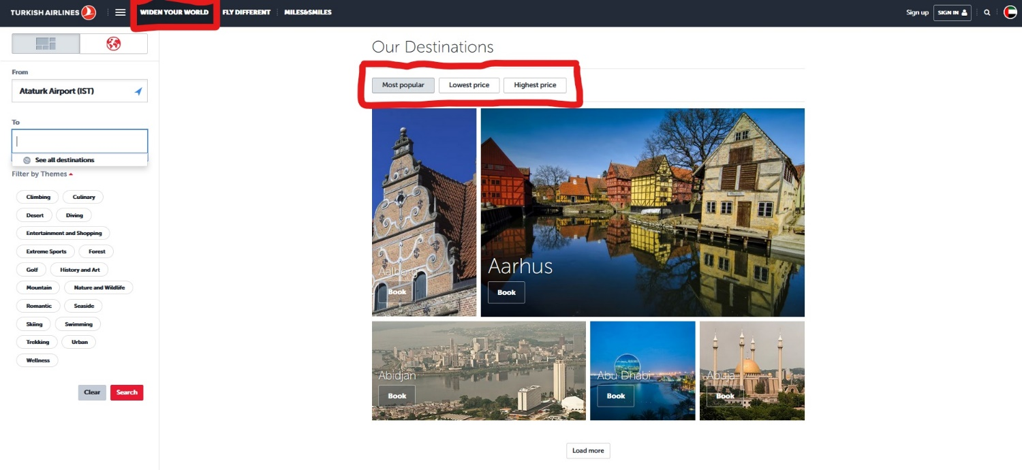experiences. It is an example that the surveys can be used in promotion in 4Ps.

[Screenshot of THY Widen New World page]

Conclusion, both surveys can be used to reach and restrict the target market to be more efficient in marketing.

**PART 2**

**Main Differences:**

1. It is possible to search on amazon.com without an account but to search on smileamazon.com it is necessary to sign in with an amazon account.
2. smileamazon.com operates with the exact same products and prices with amazon.com but the %0.5 of the price of the eligible products is donated charity of consumer decision (Bloom Worldwide, 2017).

The one of the potential reason Amazon creates smileamazon.com is decoy effect. If they use smile feature in the main website still consumers would have the same choice whether to buy or not. However, when they publish smileamazon.com they’ve created the third option is a possibility to help charities by buying products. It creates an asymmetric dominance because amazon.com becomes the inferior good with same prices, same product but without the charity feature. As a result, the main reason is to make smileamazon.com superiority but to achieve that they keep amazon.com as the inferior good.

On the other hand, it does not work in that sense. It can be explained by the term “default effect (Status Quo bias)”. It is difficult to change the website for consumers because most of the consumers get used to search on the amazon.com. Therefore, consumers less tend to use smileamozon.com.

The main reason is to create a different website “smileamazon.com” is priming the consumer. When the consumer uses the interface smileamazon.com they are attracted by the website content “Donate to a charity”. It basically misleads consumers to expand more money and makes them think as they can help to charities by buying new products, indeed they forget to truth that Amazon makes a lot of profit from the smileamazon.com and the donation is just %0.5 of the purchase price.

REPORT 4

**PART 1:**

Segmentation and targeting strategies are one of the most important factors of marketing. Segmentation means the identifying the customer needs and segment the market according to similarities. If we segment the market properly we will become more successful at the end. After that we target the market. Targeting is the evaluating market segments, focusing on one segment and ignore the others.

THY and Lufthansa are both global companies. Firstly, the target market can split into two parts as Business and Leisure for both. Also, the segments for both the targets may be gender, age, lifestyle, income, world region, life stage etc.

**Business Market**

According to Holodny, different regions have different gender ratio in business life. For example, in Arabia there are relatively more business men than business women. For these countries segmentation can be operated according to male gender. For example, in United Arab Emirates there are 274 business men over 100 business women. On the other hand, most of the countries (apart from United Arab Emirates) gender ratio are approximately same therefore, it is not the case to specify the segment according to gender (Business Insider, 2015). Additionally, business people’s ages are between 30-55 and in that ages most of them are married. Also, their income will be more than 100.000 USD per year.

As it mentioned in the previous paragraph, it is better to segment the market according to gender in some regions. Additionally, it can be researched that which countries have intense flight-flow among them, so they can change or redesign their promotions. Moreover, every country even city has different kind of tastes, choices etc. According the features of the region, country or cities, product, promotions can be changed. Especially for business people, service and comfort is crucial when they choose which airways company to travel.

For segmentation, also it is important to correspond to the life style of the consumers. Especially, most of the business people have less time and they are busy people. Therefore, time arrival can be very crucial for this segmentation. Probably, if they encounter a problem with timing issue, the would tend to change their airways company for the next time.

**Leisure Market**

For Leisure Market, segmentation is more detailed and specified compared to Business Market.

Firstly, gender differentiation is not logical because there is no direct relation between gender and buying service. On the other hand, it can split into three subsegment by different ages like 18-25, 25-40 and 40-70 because every different kind of age level has different kinds of choices and likes. For example, Amsterdam can be more attractive for young people than elder people. Another important specification is life stage and income. Specially, low income people may tend to travel to near location or cheaper destinations on the contrary, high income level people may choose far and expensive locations to visit. For example, in the website of THY, there are options in “Widen Your World” part that people can choose 3 options as most popular, lowest price and highest price. (THY,2018)

Furthermore, the geography is crucial for marketing. As mentioned in the paragraph 2 in business market, the choices, tastes and expectations from the company may differ from region to region, country to country even city to city. For example, there may be some cities which are divine for some religions and naturally, there will be more interest to these kinds of cities from the countries which has more people with same religion. Another example, a service sandwich may be more liked by costumers from a country, but the same sandwich may be liked less by consumers who are from different country.

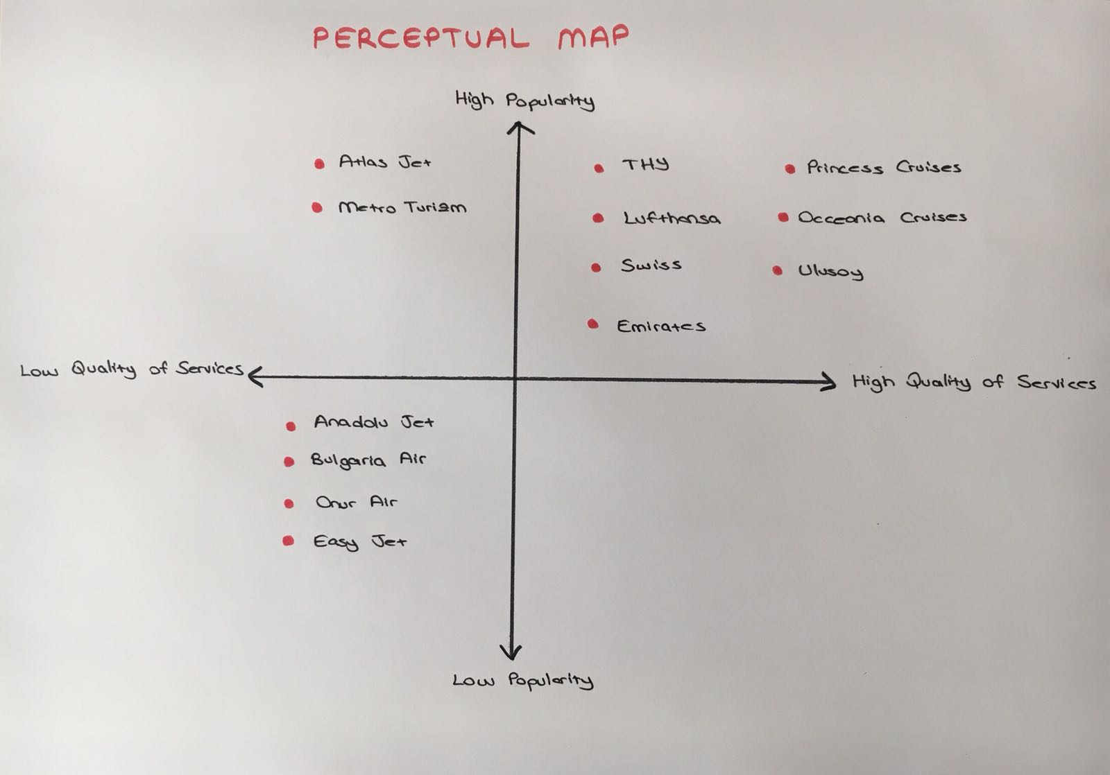 Also, lifestyle is very crucial for segmentation. The lifestyle can give clue about what kind of occasions would be effective in promotions. For example, if there are enough people who are interested in sports events, there will be a tendency to buy ticket to where there is a huge sports competition etc. As similarly, as mentioned in the Report 4 personality also is important part of segmentation. As it can be predicted, in the leisure market, the ones who give more importance to life-experiences would tend more to travel and see new locations. Therefore, for both airways companies it is better to focus on life-experience customers. More precisely, there are huge number of teenagers from low or average income who haven’t travelled to abroad. Both THY and Lufthansa may do research, experiment and survey to analyze the level of openness to experience and they may come up with a new service for that segment unless the segment is not sufficient enough to be invested

**PART 2**

**NICHE MARKETING**

**-** Niche marketing is defined as a narrow, small marketing strategy that develops to better meet the needs and desires of a small consumer group with similar characteristic needs that require goods / services.

- This marketing method does not carry the major market feature.

- In this marketing type divide the target group into categories and divide by the areas of interest. It is very important in terms of marketing method that you clearly describe what kind of product or service you will offer on the market you are leading and introduce this product and service to your target.

- Niche Marketing is a clear example while producing expensive and luxurious vehicles that only a certain segment can buy. Mass marketing example of how a car company can produce all sorts of vehicles at affordable prices, while it is a model for Mass Marketing.



- For example, Lamborghini’s targets are

*Age over 30’s

*High income

*Rich premium personalities, celebrities.

- Lamborghini’s are selling really high prices all over world. We can call it they made it for niche marketing in which car can cost upwards of $500,000.

- For example, few people like Lamborghini and buyer population is different. The niche marketing method is the result of filling these gaps.

- If this niche marketing example is differentiated marketing strategies can target more than one segment, Lamborghini, for example, can produce vehicles with lower engine volumes and lower horsepower to reach 2 different target masses. They can make both sporty and less powerful cars.

- With this segmentation the company can diversify their target consumer, for example Mercedes have different motor types in same model and they are in the super-sport car category. They have the lower engine types at C Class for example C180, C200D and, they have C63 AMG. They are totally different goal for selling strategy.

- If Lamborghini company use this segmentation strategy they have same opportunity with the Mercedes, same products in vehicle with different motor-type and horsepower.

- If they use this strategy they can wider their target scale for example; some of the college students wants to be cool as using super-sport cars and get a chance to use such a car at more affordable prices.

- People who wants to drive a super-sport car, but they are not a billionaire, they can buy this car with lower prices than the original version.

**QUESTION 3**

**MANFLUENCERS TREND**

According to John Johnson, manfluencers trend is the new marketing trend which is overturning the notions of gender roles in the supermarket and in the kitchen (Newser,2013). The companies design their products to catch the attention of guys. If we can give an example for that products this can be a yoghurt which named “Powerful Yoghurt” and designed for the man. This yoghurt includes more protein and the package of the yoghurt is produced with bigger servings and designed with the pictures of bull horns with the colors of black and red.

Also, according to Jennifer Abel this trend is against the gender inequality. There are women- based products in the market but no special products for the man. These products serve for gender equality and makes man to buy these products much more.

2 examples of brands that have responded to that trend:

1) Kraft Foods Group Inc.

2) General Mills Inc.

What about your brands? Do you see any potential for your brands to take advantage of that trend?

Both Turkish Airlines and Lufthansa Airlines can create some advertisements in terms of manfluencers trend. For example, compared to women, men probably fly with their children less in average. There can be discount for men who fly with their baby and, there can be an advertisement to encourage to fly with the kids(babies) for men. For instance, THY has a sponsorship with Barcelona football team. They may give a gift (tickets to El Classico with his family etc.) to the father who fly most with his baby in a year and call him as the father of the year. There can be such advertisements and events to respond the trend “manfluencers”.

REPORT 5

1. **Product Line Decisions:**

THY has variations of products for same functionality, need and same target(customers). Therefore, THY has another brand as Anadolu Jet. They basically target same need under different brand-name, lower prices and different names. This company seems to not belong to THY to not hurt the prestige of THY. This product line decision is called downward stretching. Although, there is a potential risk of cannibalization for THY, they manage this risk almost perfect therefore, there is no harm in terms of brand-image of THY.

THY and Lufthansa also have different types of lounges as CIP, VIP and target different target markets by having different kinds of tickets as First Class, Business Class and Economy Class. It can be called as filling (same brand-name different market). These are varieties under the same brand-name. This is called filling.

THY also own Turkish Cargo which available to transport any kinds of goods across the globe. Another example is that Lufthansa has Lufthansa Cargo which operates around the globe. Also, THY own Turkish Airlines Flight academy which offers flight services and training cadets. This is Product Mix in terms of product line decisions or these examples can be called as Brand Extension in terms of brand development.

1. **Widen Your World:**

THY introduce a new option in their website Widen Your World and they basicallytarget the people who interested in new experiences (or basically travelling, discovering etc.). They make a YouTube advertisement to promote and attract these kinds of consumers. In that promotion, they have reached approximately 87 million views, it proves the huge success of this promotion. Additionally, they create option to have choice of price and location to target different income level of consumers.

**GENERICIDE**

A brand's use as a product name by losing its distinctive identity. This may lead to the

brand losing its title. The process by which trademark rights are diminished or lost

because of common use in the Marketplace. For example, while SelPak is a brand of

handkerchief, it is now used as a product name because it is called SelPak instead of a

handkerchief.

There is no example about ‘genericide’ for Turkish Airlines and Lufthansa Airlines.

Also, there is no potential risks for The companies.

**EXAMPLES**

**JBT AeroTech**

Jetway: The name commonly used to describe a closed road that extending from the terminal door to the aircraft. It also used in transit from ship to the port / port to the ship and from ship to ship.

The original name of Jetway is “Passenger Boarding Bridge”. However, the

company JBT Aero-Tech used the word ‘Jetway’ instead of ‘Passenger Boarding

Bridge’ at 2005. After that, the term ‘Passenger Boarding Bridge’ started to be mentioned as Jetway. Therefore, the is complainant about this situation because they cannot get their trademark rights of ‘Jetway’ since it became a generic term amongst everyone. For instance, other brands started to use jetway too, so the company couldn’t demonstrate jetway as a trademark. Overall, company started to become synonymous with “jetway” and the company was left in the shadow.

**ASPRIN**

Bayer AG produces Aspirin for headache and it becomes trademark over the World especially during World War 1. As a result, everybody has started to call the bills for headache or etc. as aspirin and the brand-name was left in the shadow (Consumerist, 2017)

REPORT 6

**Question 1**

|  |  |  |  |  |  |  |
| --- | --- | --- | --- | --- | --- | --- |
|  | Automobiles | Frozen Dinners | Jeans | Athletic Shoes | Beauty Supplies | Cosmetics |
| REHA | 75.000 TL | 20 TL | 200 TL | 400 TL | 60 TL | 100 TL |
| EYLUL | 180.000 TL | 30 TL | 300 TL | 800 TL | 100 TL | 200 TL |
| SENA | 150.000 TL | 25 TL | 200 TL | 600 TL | 150 TL | 350 TL |
| BERK | 200.000 TL | 20 TL | 300 TL | 500 TL | 100 TL | 200 TL |
| NESLIHAN | 300.000 TL | 20 TL | 200 TL | 600 TL | 100 TL | 300 TL |

These are the WTP list of each team member for the following products. Each of us have different perceptions of value. Those differences exist because of some reasons. Those reasons may be ;

1. **Interest**

Each team member has different kinds of interests. For example, women have much more interest in cosmetics than men. So, women have higher WTP to cosmetics. Our interests in products affects our decisions to pay for them.

1. **Income Level**

The income level can also specify the WTP value. Each of us have unequal income levels. This inequality limits our WTP decisions. If we do not have enough income level to buy something we want, we cannot reach our goal.

1. **Familiarity**

Familiarity also another important factor that affects our decisions when we are buying products. If we are used to some specific product and we get satisfied when we are using them, we generally prefer them without looking their prices. People mostly choose the products they get used to it and this situation throw the prices out of focus. Also, every person’s familiarity with the products is different from each other.

1. **Prestige**

The prestige of products can influence our choices. If the product is popular and have high prestige, the WTP can get higher. The prestige and the WTP have directly proportional relationship. As an example, automobiles have lots of prestige for Neslihan and she gave the highest WTP value between us.

1. **Experience**

In addition, the experience we gained from the products determines the WTP value we gave. If I get some good experience from the athletic shoes and they give me some comfort I will give higher values of WT. In comparison, if someone gain some bad experiences from athletic shoes like easily damaged ones they want to give lowest prices to them.

**Question 2**

**Comparing Prices**



**https://www.turkishairlines.com**

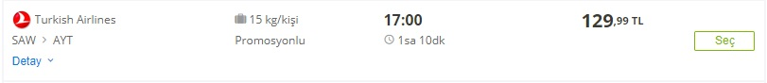

**https://www.enuygun.com**

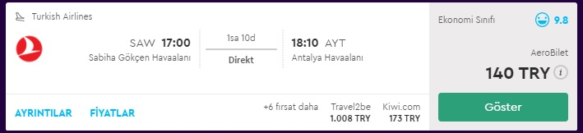

**https://www.momondo.com.tr**

There are many factors that play a role in the pricing of a product. pricing methods used at internet cost are based on some of these factors. While shopping on the internet, the website uses customer profile and dynamic pricing to determine the price.

**Consumer profile:**

The customer profile is formed when the internet users input information about their search history. Using consumer profiles for e-commerce sites is a bit complicated because people do not just stick to a website, but online companies have to market the product appropriately and market it to the right person. However, constant change of consumer profiles makes this process difficult.

**Dynamic Pricing:**

When someone looks at a flight from a computer, that computer cookie pops up. the price of that flight becomes higher than it was before when the same name is entered to same fly for the second time.

Some internet sites selling plane tickets can have a lot of tickets at a very cheap price because they have already bought tickets. They sell these tickets on their internet sites by putting a small profit on their tickets. While the price for the main company is rising, other internet sites can stay under that price. Likewise, as the number of tickets in the hands of the ticket-selling site decreases, the firm may prefer to sell fewer tickets with higher profits. For this reason, Turkish Airlines' ticket prices are lower than other internet sites in the above example.

**Question 3**

**Behavioral Tactics**

1. **Precision Tactics:**

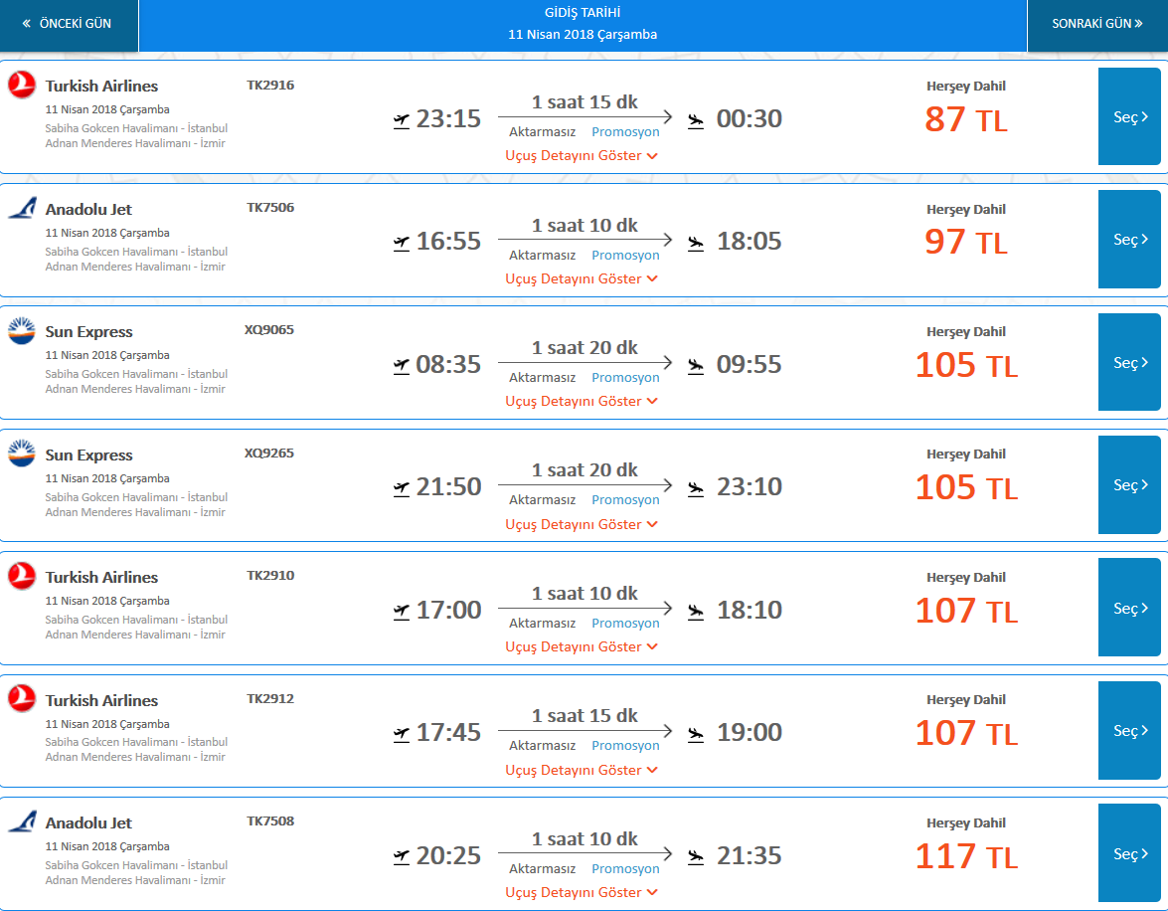Precise prices make consumer feel that prices are more realistic, calculated, and fair. Therefore, consumers will prefer more precise prices over not precise prices.

1. **Bundle Tactics:**

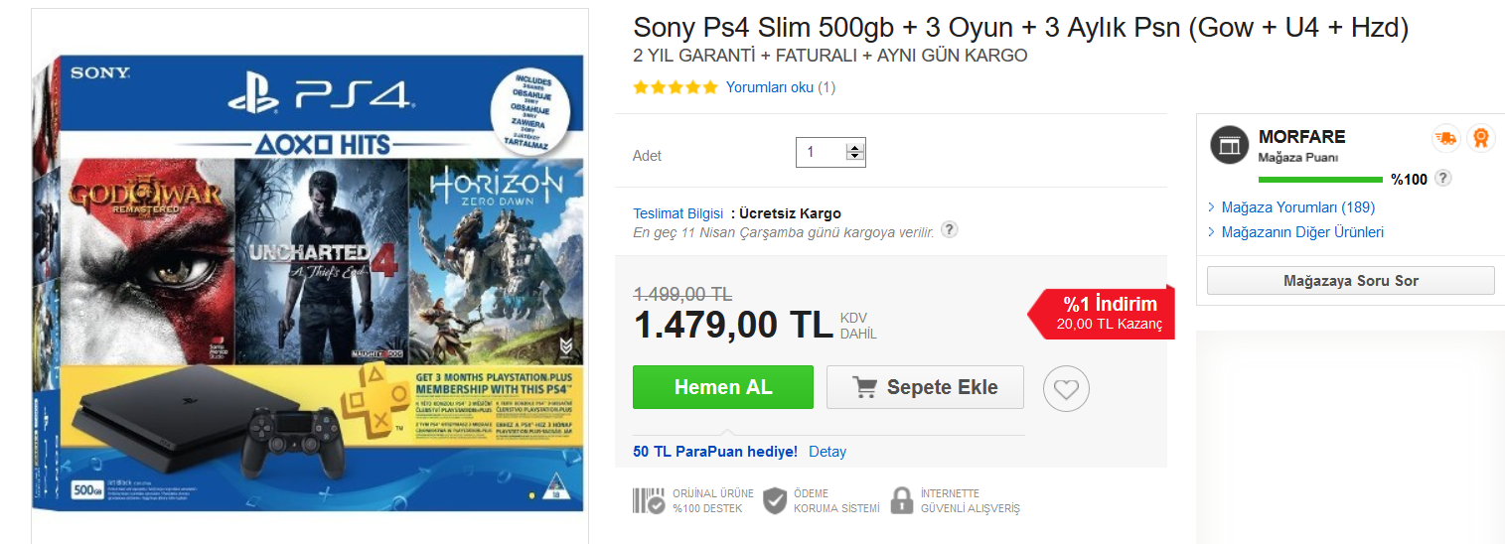Due to prospect theory, consumers prefer bundles over single product because they prefer combining loses.

1. **Odd Tactics:**

Consumers generally look at the first digits of the price. Therefore, odd prices make people think that the price is more favorable than the classic price.

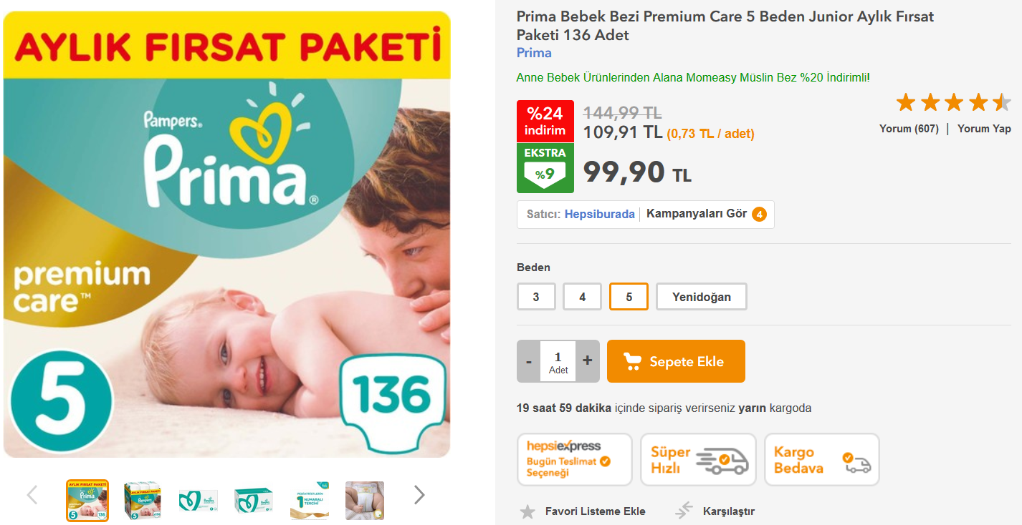

REPORT 7

**Youtube Advertisements:**

**THY**

**5 Senses with Dr.Oz:**

In this advertisement Thy basically aims the people which give more importance to life experiences, They point the five senses which the people feel all over the World. Furthermore, the add have subtitles in 29 different languages. Moreover, they have designed a website option as “Widen Your World” and they have reached approximately 87 million views on YouTube. As a result, they gain positive image and quality with the add and it is very successful advertisement all over the World

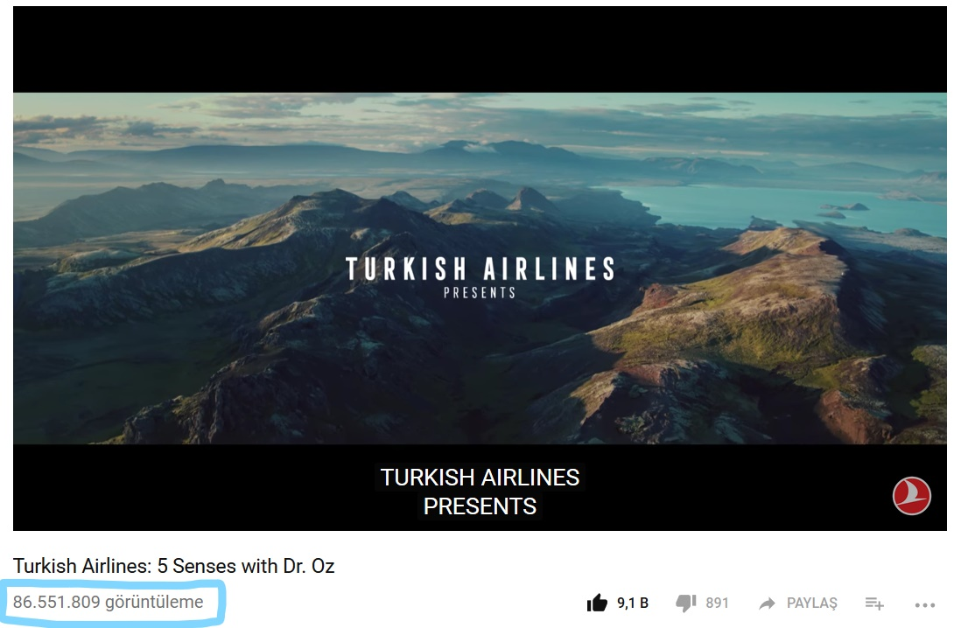

**Kobe vs Messi: Legends on the Board:**

The advertisement basically aims to create the perception “the best airlines in Europe” by using two legends in the most popular two sports(football and basketball). Two legends are competing to take the attention of the regular kid but finally, the ice-cream of the service take the attention of the kid. This is quite a successful advertisement which has reached approximately 120 million views. As a conclusion, the advertisement basically aims to show the quality and increase the popularity over the World

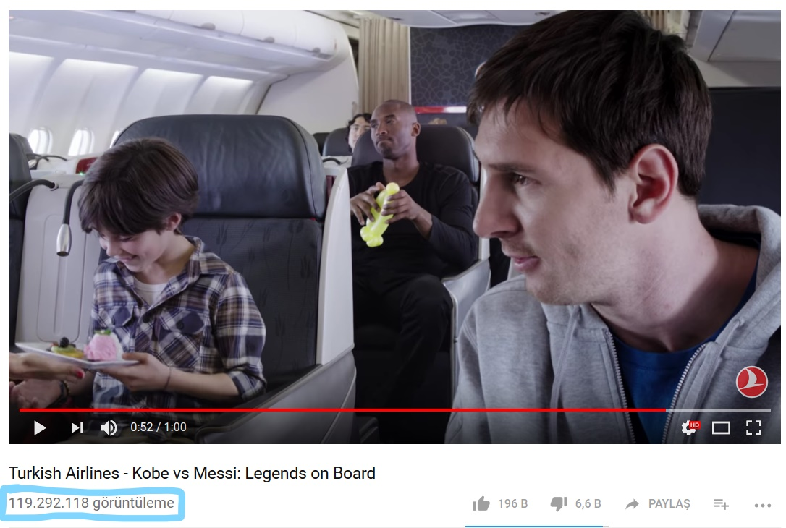

**Kobe vs Messi: The Selfie Shootout:**

The advertisement claims that Thy is the airline which has more destinations than any other airline in Europe. The advertisement shows the claim in a pretty entertaining way by using the best two sportsmen of the recent times. As a result, Thy gives the image of prestige and quality and also again they target the people who give more importance the life experiences. They have reached almost 148 million views and this the record for Thy.

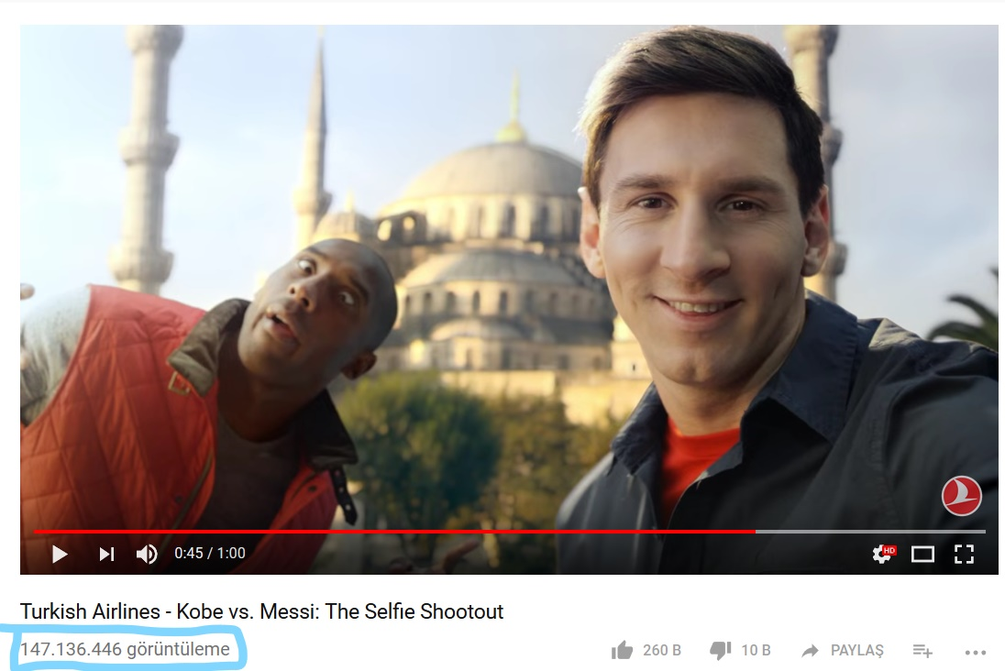

**Lufthansa**

Compared to Thy, they are less successful in the platform of YouTube and they have just one important advertisement. This shows that Thy is more successful and they make more an effort of advertisement on YouTube.

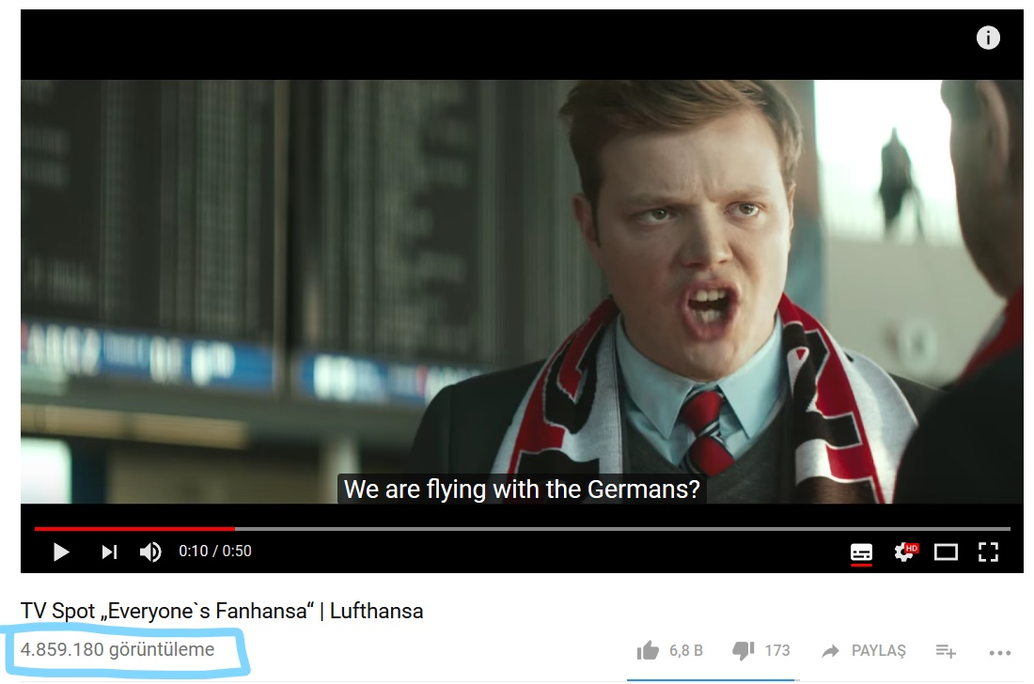 This advertisement is quite funny. Especially, they want to destroy the perception of the German companies and people also show the quality of their flies. However, compared to Thy which has 29 subtitle languages, they have only two options German and English. The views around 5 million which quite a large number but again it cannot be compared with Thy. As a result, they want to destroy the German perception of the foreign people on their company with an entertaining advertisement.

**CSR Activities:**

**THY**

**Fuel Efficiency Program:**

Thy starts to cooperate with IATA to increase the fuel efficiency and decrease the carbon emission. To achieve the goal they separate the operations into three sub-groups:

1-Optimizing the Operations: The have decreased their carbon footprint by more than 70 projects (increase the efficiency of the airplanes, educating the plots etc.)

2-Investing in New Technologies: They ordered new airplanes which have 15% less carbon usage and they will start to operate with them in 2021

3-Improving Infrastructure: They have created a team to improve the traffic management system. They basically do some research to find the best operation road for airlines during flies etc.

**Flight Safety:**

Thy aims to have the best health conditions for both consumers and the workers during flies. They work with Quality Management System(QMS) and Safety Management System(SMS). QMS and SMS verify the safety of Thy without missing. Also, they are a major member of Star Alliance which is known all over the World.

**Social Responsibility Projects:**

With European Basketball organization, they have created the Project “One Team”. Their aim is to reach the people who are disadvantaged in terms of physically and mentally by using basketball as a helper medium. 15 teams are included in this Project and it helps to reach 9 countries in Europe. (Environmental and Social Responsibility Report, No-Date)

**Lufthansa**

Lufthansa has an agenda in terms of CSR:

1) Economic Sustainability

2) Cooperate Governance and Compliance

3) Climate and Environmental Responsibility

4) Social Responsibility

5) Product Responsibility

6) Cooperate Citizenship

Also, they have committed the sustainability of United Nations. They have arranged their working conditions in terms of climate change, use of natural sources, female employees etc. (Cooperate Responsibility Within the Lufthansa Group, 2018)

**Events:**

**THY**

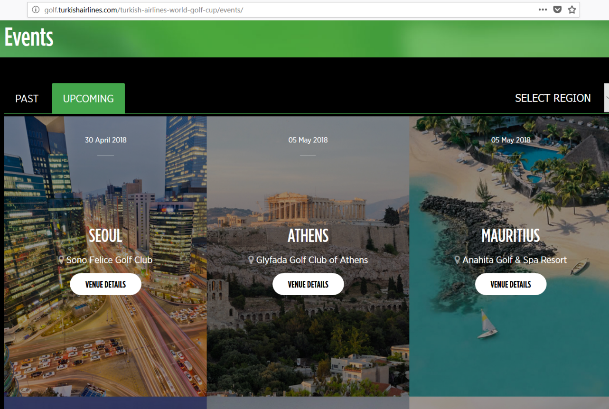**The Golf Clubs:** Thy has a sponsorship with the golf clubs around the World.

**Cooperate Group:** This is a group for business people which give some discounts and special proposal but also under these group there are some events across the World.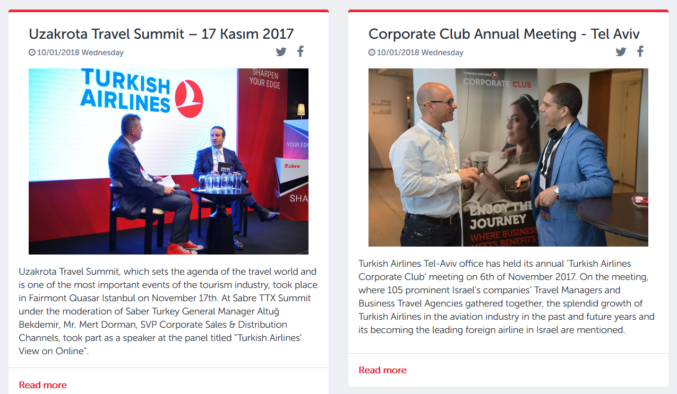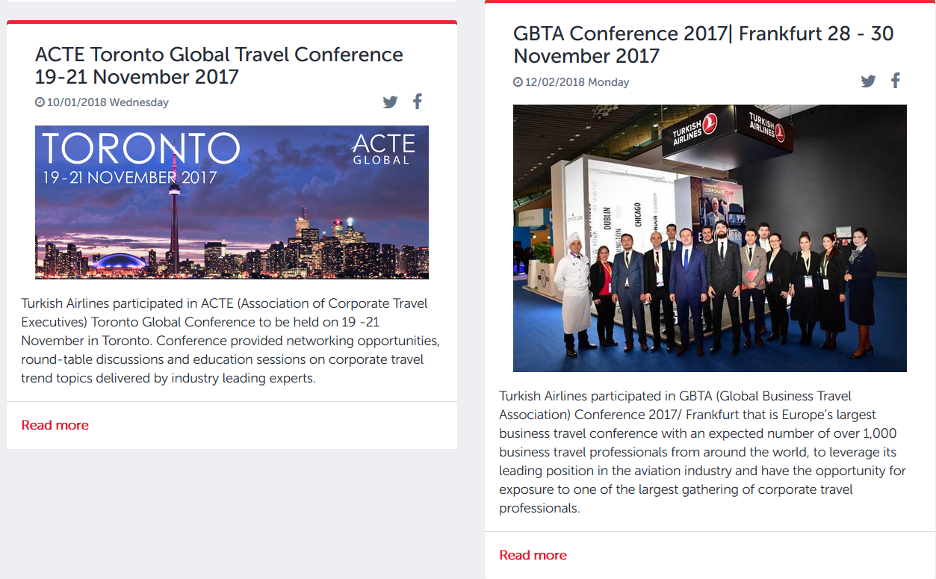

**Lufthansa**

**Meeting and Events:**

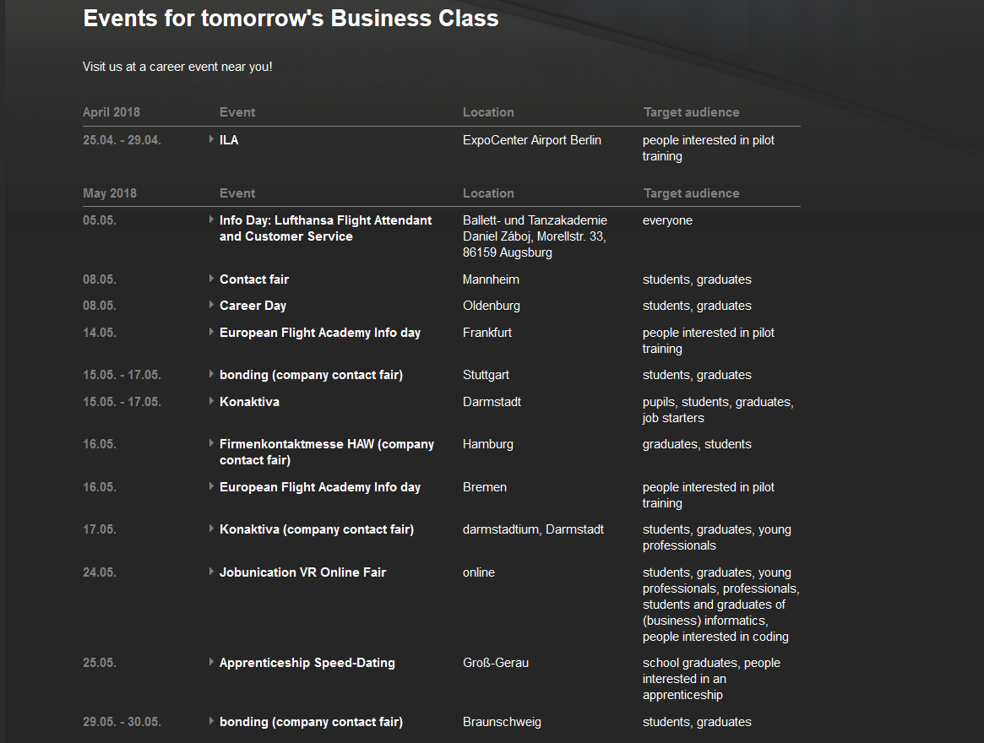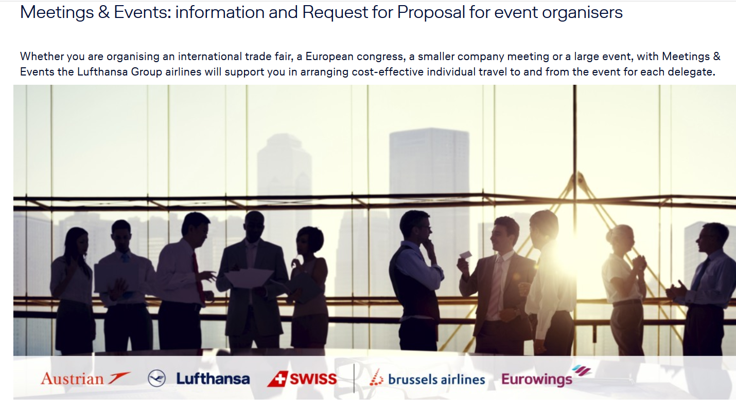 They basically aim to reach the sponsorship of the events for the large or small events so, they have created a website interface to attract the customers of such events.

**Web Advertisement**

**THY**

**Google-Ads:**

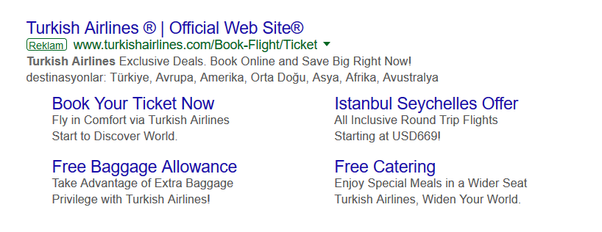Clearly, THY uses Google-ads to reach more people on Google search and websites which are searched through Google.com

Also, as mentioned in the youtube section, they are very good at youtube advertisement and probably Thy is the most successful user of YouTube among the airline companies.

**Lufthansa**

**Google-Ads:**

Clearly, Lufthansa uses Google-ads to reach more people on Google search and websites which are searched through Google.com

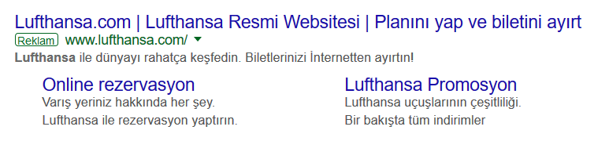

Also as mentioned in the youtube section, they exist on youtube advertisement and they have shared some advertisement through their Youtube channel.

**THY and Lufthansa**

1) Sponsorships

2) In-store Displays

3) Social Media Presence

4) PR

5) Product Placement

**Social Media Presence**

Social Media plays a really important role in our lives and it also helps the brands for improve and exposure themselves in online marketing. Companies should build strong, valuable and popular social media presence for their brands. With the help of the social media, brands build relationships with everyone and can easily announce their names. Nowadays, Facebook, Twitter, Instagram are one of the most popular and active social media networks and all the big brands have official counts on them.

**Turkish Airlines**

At Twitter, Link: <https://twitter.com/turkishairlines>

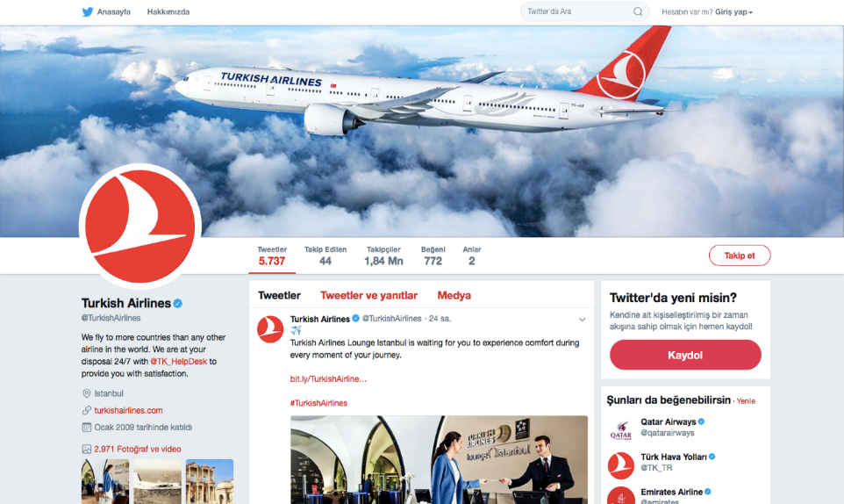

At Facebook, link: <https://www.facebook.com/turkishairlinesTR/?brand_redir=90430042759>

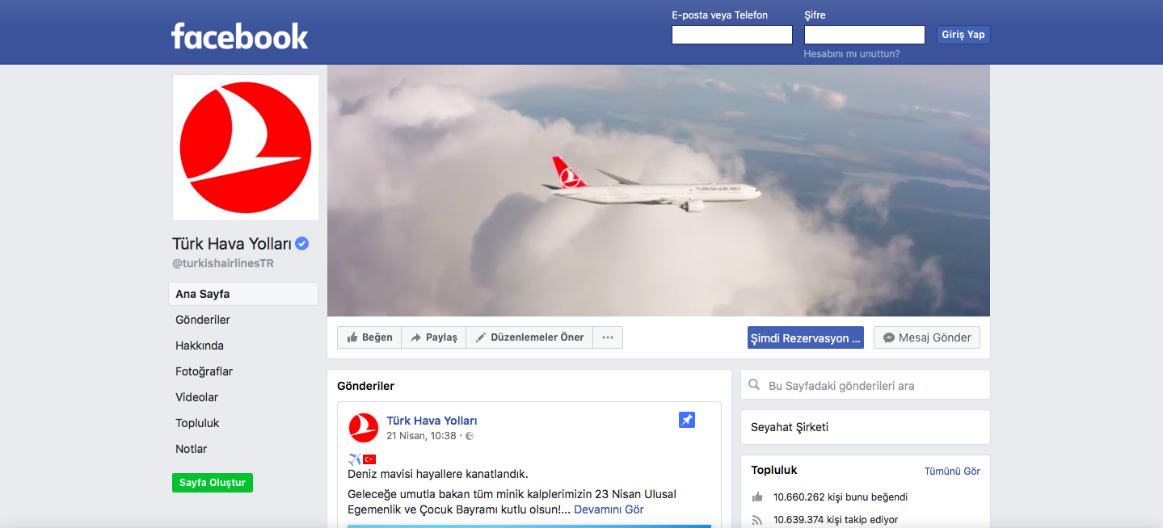

At Instagram, link: <https://www.instagram.com/turkishairlines/?hl=tr>

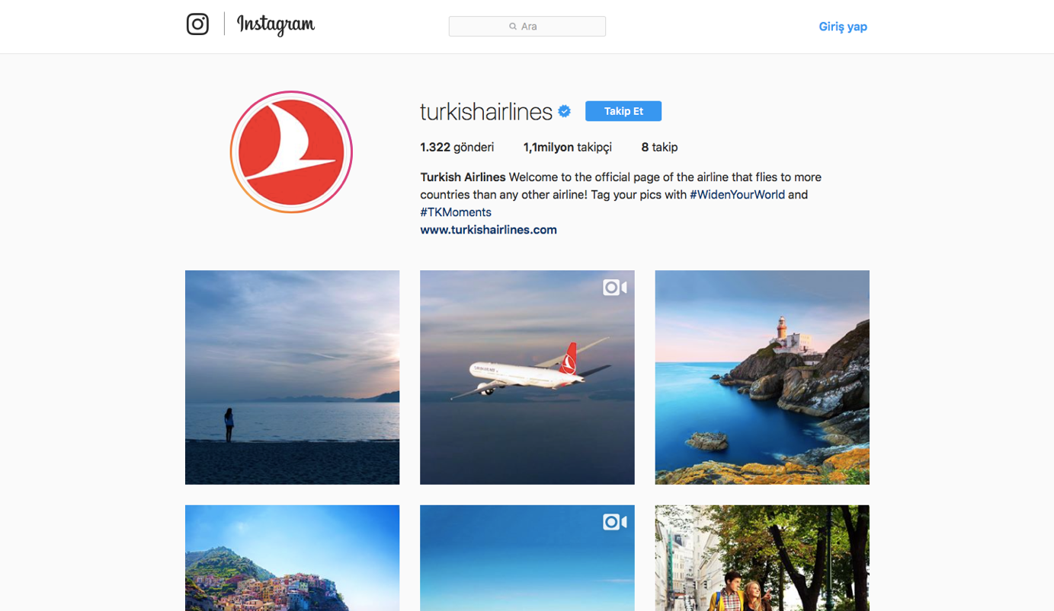

**Lufthansa Airlines**

At Twitter, link: <https://twitter.com/lufthansa?lang=tr>

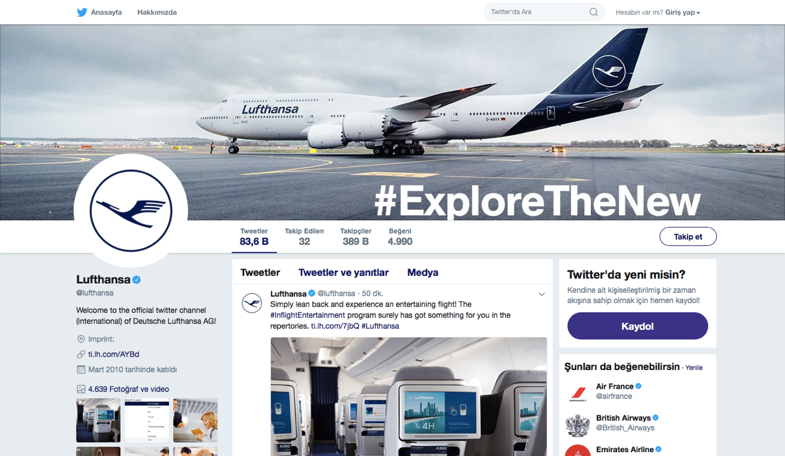

At Facebook, link: <https://tr-tr.facebook.com/Lufthansa/>

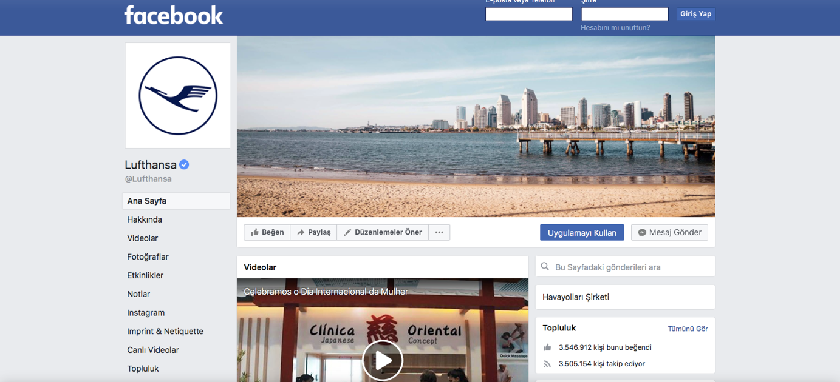

At Instagram, link: <https://www.instagram.com/lufthansa/>

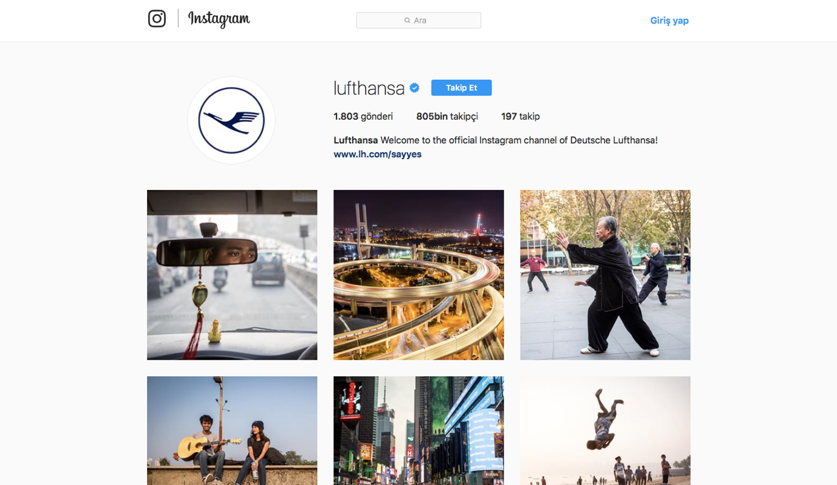

As we can see, both of our companies are active in social media networks. According to follower numbers, we can understand that THY does a better job at social media presence and THY is more popular brand compared to the Lufthansa Airlines in social media.

**Sponsorships**

Sponsorship is a significant element of today’s marketing communication. Making assertive sponsorships will exposure your brand, make attributions on consumers and help the companies for building good relationships and organizations.

**Turkish Airlines**

THY believes that “strong supports bring with it new success”. They are proud to be leading sponsor of sports both in Turkey and the world. They also host the events around the globe.

1. **Turkish Airlines World Golf Cup**

“The Widest Reaching Corporate Golf Tournament in the World.” 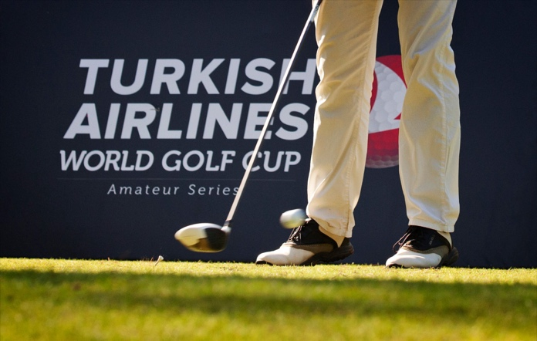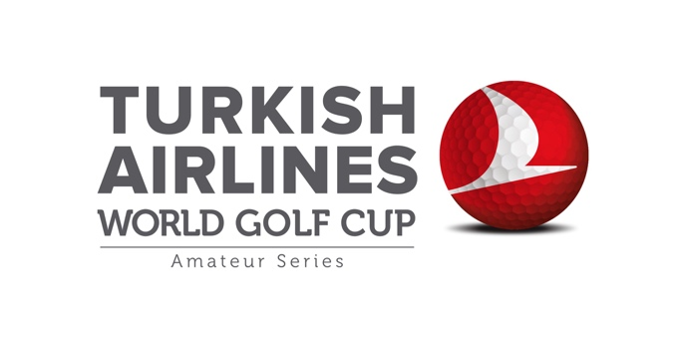

1. **Porsche Tennis Grand Prix**



1. **Turkish National Football Team**

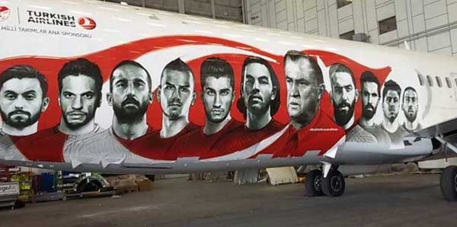

1. **UEFA Euro2016**

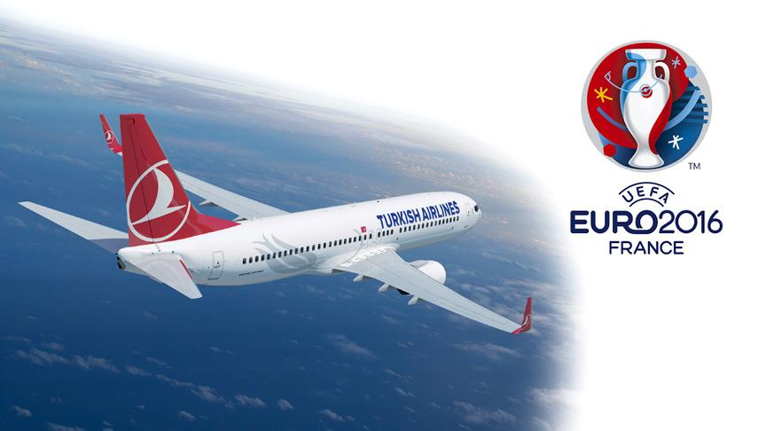

1. **FC Barcelona**

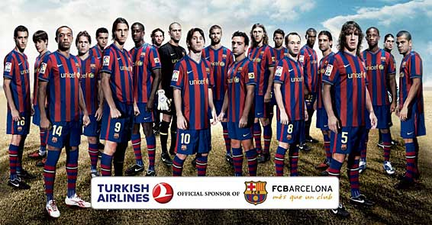

1. **Manchester United FC**

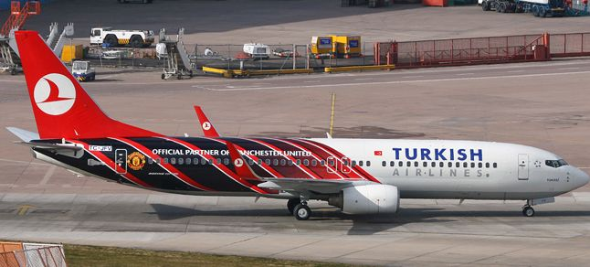

**Lufthansa Airlines**

Lufthansa Airlines also cares about the worldwide connections.

1. **Bayern Munich FC**

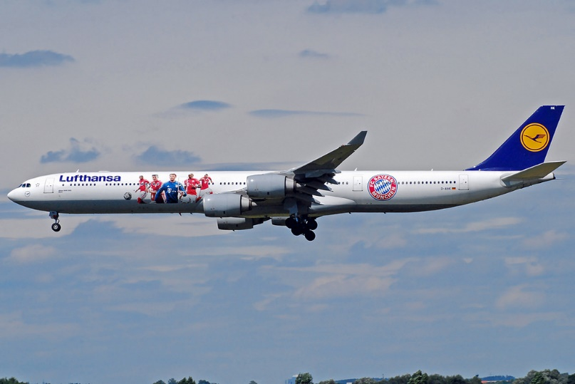

1. **German Olympic Sports Confederation**

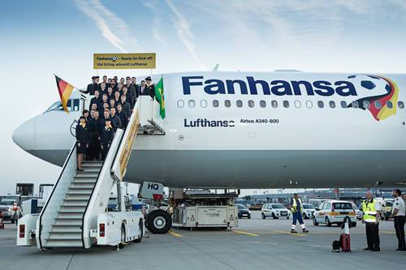

If we compare our both brands Turkish Airlines and the Lufthansa Airlines, THY does a better job at sponsorships and they announce their name more in the world.

**Product Placement**

Product placement is an advertising technique used by companies to announce their names and products or services through appearances in films, televisions or social media. It is an effective technique to influence people with the help of visuals. Both of our companies use product placements in the movies and series.

**Turkish Airlines**

**Batman V Superman**

Successful airline placements in Hollywood films, the Turkish Airlines placement marks the first product placement in a major motion picture for Turkish Airlines and extends Turkish Airlines' global reach into the US market.

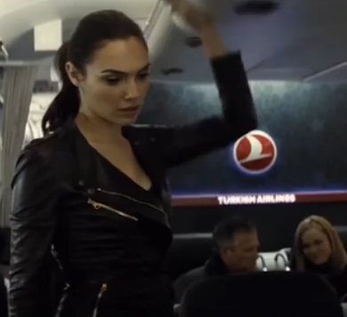 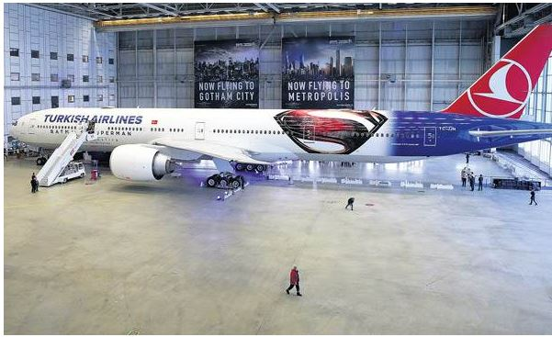

**Lufthansa Airlines**

**Anon (Netflix)**

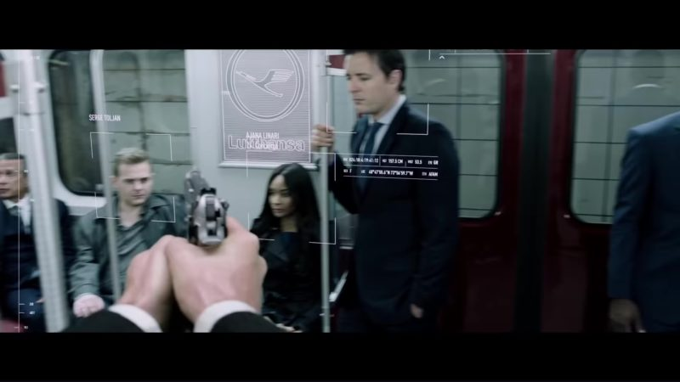

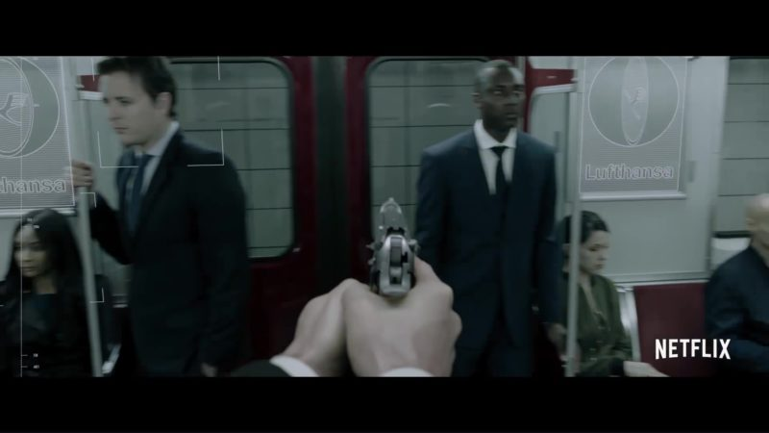

**PR**

PR (Public Relations) aims to maintain the image of a company, individual or an organization in the eyes of public. It effects the opinions and the behaviors of the society. In addition, PR gives importance to dignity. Companies should form strong public relations and make themselves an important figure in the eyes of people.

**Turkish Airlines**

Turkish Airlines have lots of PR activities. According to PR service of THY (Turkish Airlines Inside PR Work,2014), they divide their PR activities in 4 parts;

1. Media: THY makes trips and organizations for press and they try to develop local strategies for press.
2. Regional Marketing; THY provides supplier routing services and present local promotion proposals.
3. Planning; THY makes communication plans and analysis of their target.
4. Reporting/Measurement; THY prepares reports for each action they carried out properly.

Also, Turkish Airlines leads lots of activities like special celebrations (anniversaries) and projects.

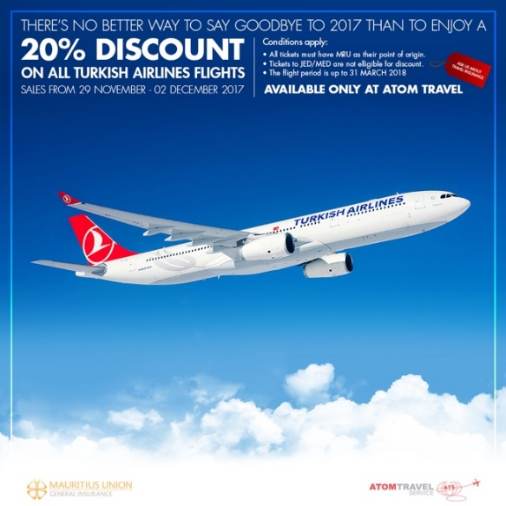

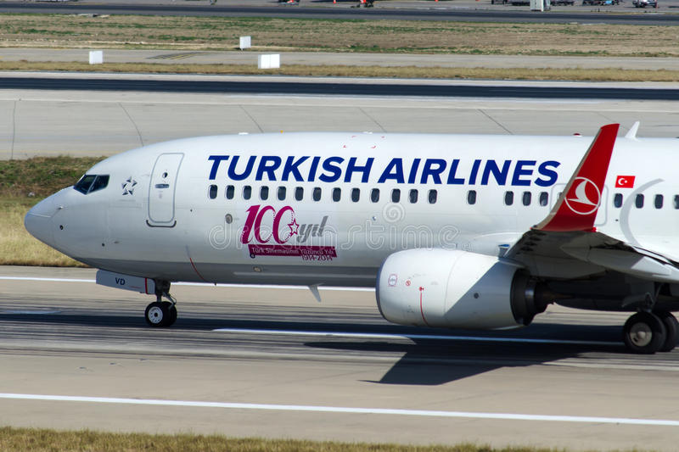

**Lufthansa Airlines**

Lufthansa Airlines does a good job at PR too. They have a separate part to announce their new developments in their official website called “Lufthansa Group Newsroom”. In this part of the site, they share their current news about Lufthansa Group. Also, they have international press releases from North America, Latin America and Asia-Pacific. In addition, Lufthansa Airlines report their financial movements and present their latest financial news to the public. Furthermore, they have a second count on twitter apart from their official count called “Lufthansa News”. So, they share their latest news in the fastest way to the world.

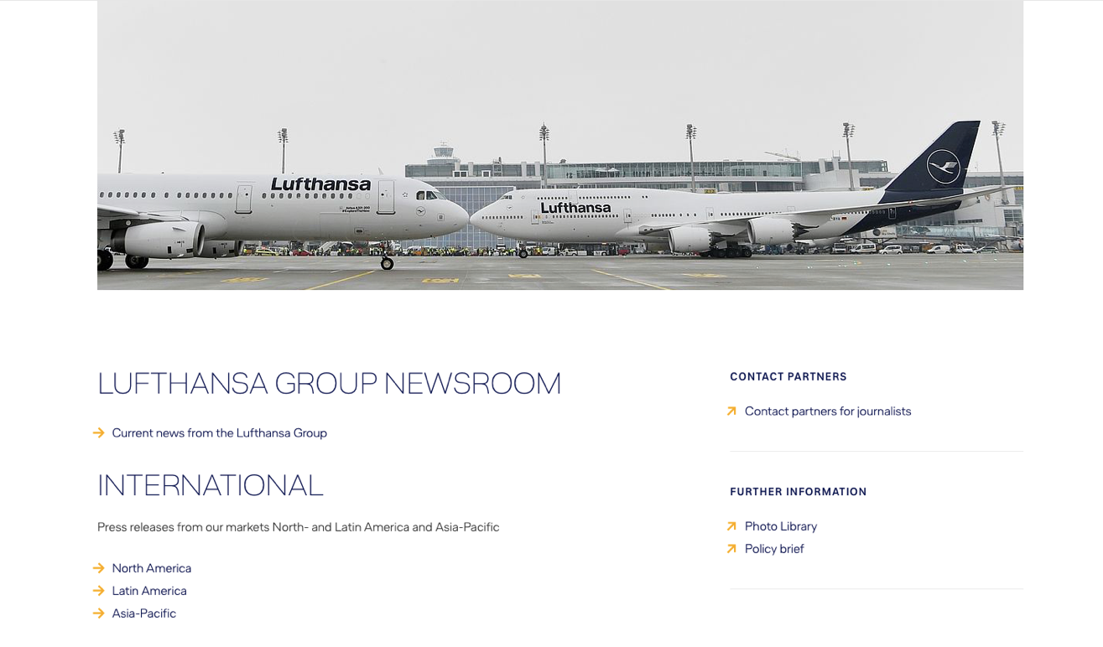

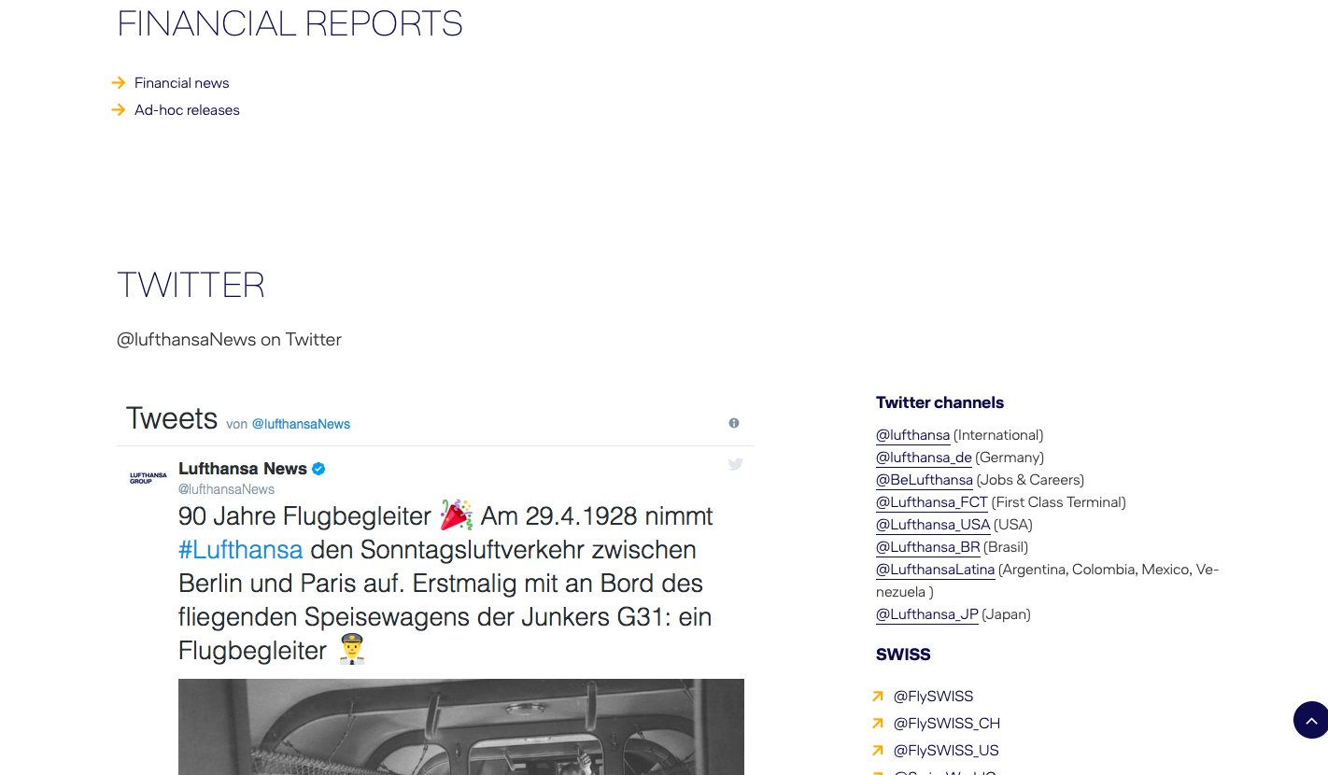

**In-Store Displays**

In store display is an attractive and effective way to influence people. Both, Turkish Airlines and Lufthansa Airlines do not have stores, but they have counters in the airports. More importantly, they make their planes more attractive by illustrating the outside of the plane. Also, they design the inside of the plane according to comfort of the people.

**Turkish Airlines**

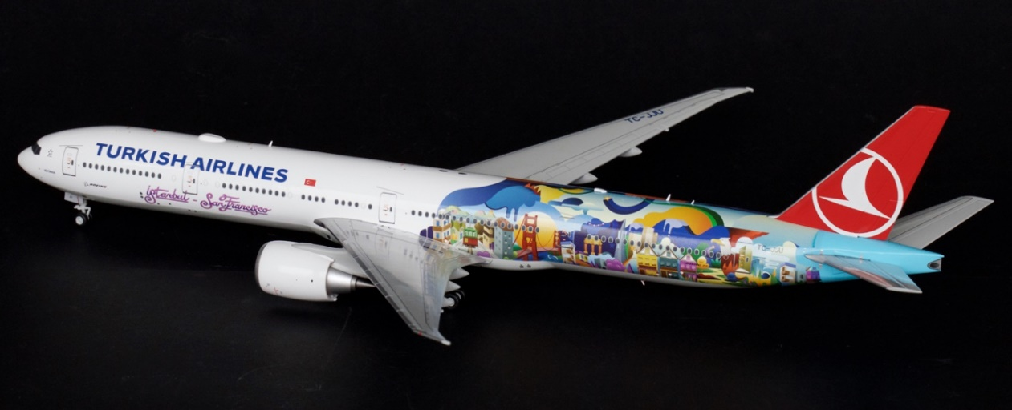THY uses different decoration techniques when they design their planes. By this way, they draw attention and people may sympathies them more easily.

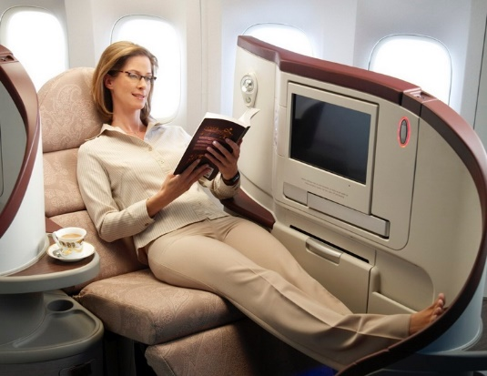

**Lufthansa Airlines**

Lufthansa Airlines uses the airports to make them in-store displays. Also, they give importance to comfort and the inside design of the plane.

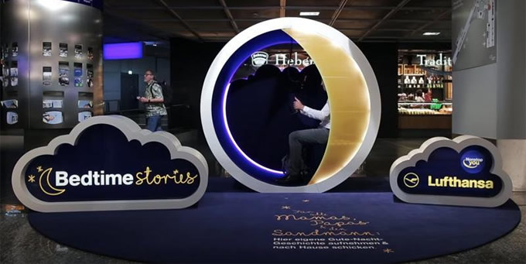

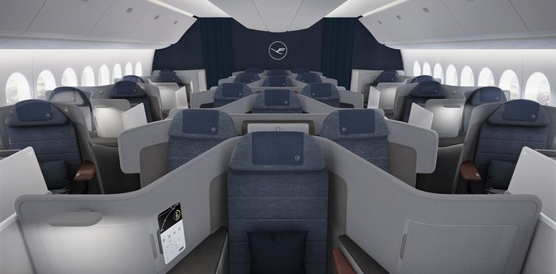

**THY and Lufthansa**

1. E-mail
2. TV, magazine, radio, billboard, magazine
3. Catalogue
4. Store Design
5. Brochures

# E-Mail

Consumers check their personal emails daily, reaching them via email is essential when it comes to informing customers about promotions, deals and improvements. Even though you have no plan of traveling these new deals informing mails are good encouragement to plan your trip.

## **Turkish Airlines**

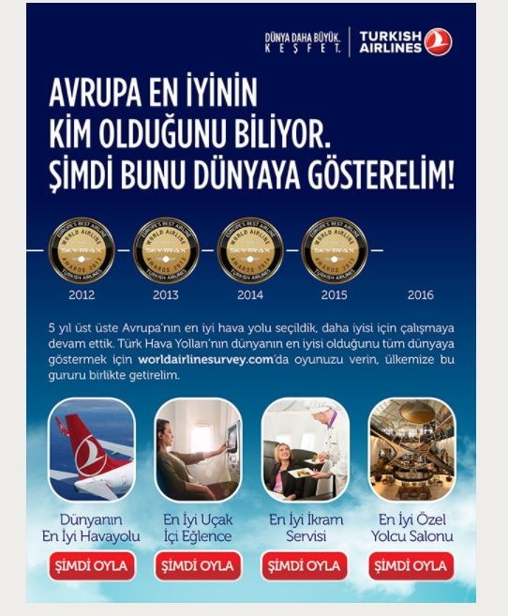

Turkish Airlines uses Email not only for ads and promotions but also to show their success to gain trust of their present and future customers.

## **Lufthansa**

Lufthansa tries another approach by showing you your miles to encourage you to plan more trips.

**TV**

Television can be traditional media but can adapt to new media. Tv ads combine sound and sight, has ability to reach national and global market and audience.

## **Turkish Airlines**

Turkish Airlines know what audience wants to see and can react in different forms of emotions. They reach their audience in a local way, they target not only higher class but everyone from every culture and income level.

## **Lufthansa**

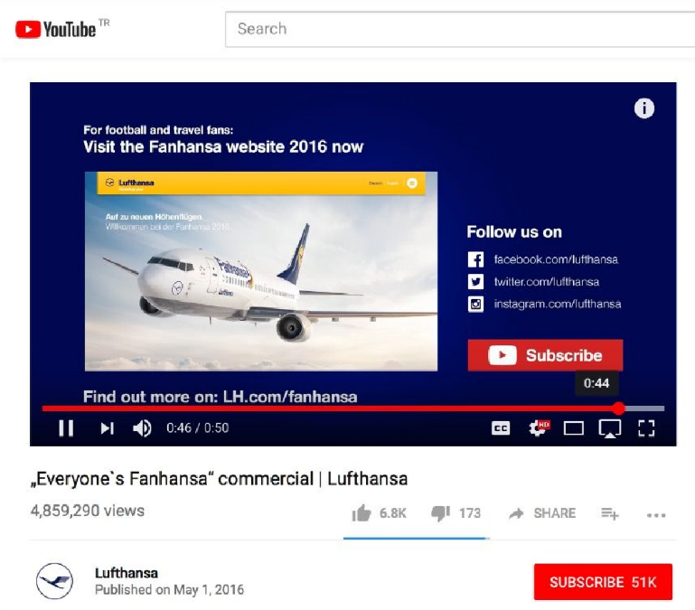

Lufthansa has a different approach which is also powerful because they are trying to reach a people from everywhere. Their audience is global. They combine cultures for their ads.

# Radio

TV and radio are two customary promoting devices that don't require the conveyance of data in a physical shape. Television and radio promotions can achieve a great many purchasers all at once.

## **Turkish Airlines**

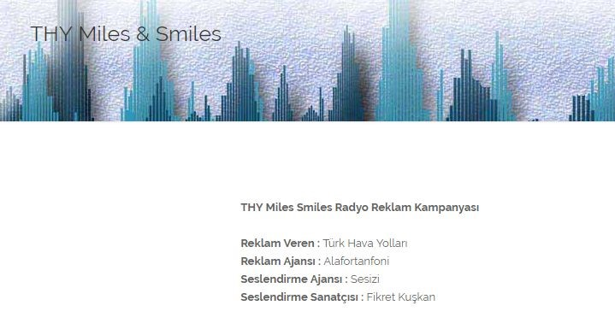Turkish Airlines uses voice of famous people, we recognize from their voices in their ads. While we are listening tunes, we hear that's familiar voice which informs us about the brands deals.

## **Lufthansa**

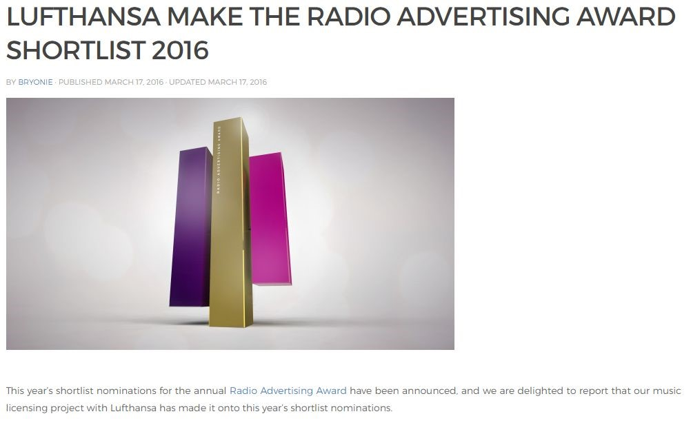

They take a more thoughtful and dedicated approach. Because they are not a brand for everyone they make radio ads with elegancy and serious matter.

# Billboard

Print and outdoor advertisements relay information to consumers through physical format. Examples of outdoor advertising include billboards, signs and posters. Print and outdoor advertising can direct consumers to other advertising channels, including company websites and web-based social networking platforms.

## **Lufthansa**

They try to reach a local crowd via local billboards. They target only the person who sees the billboard.

## **Turkish Airlines**

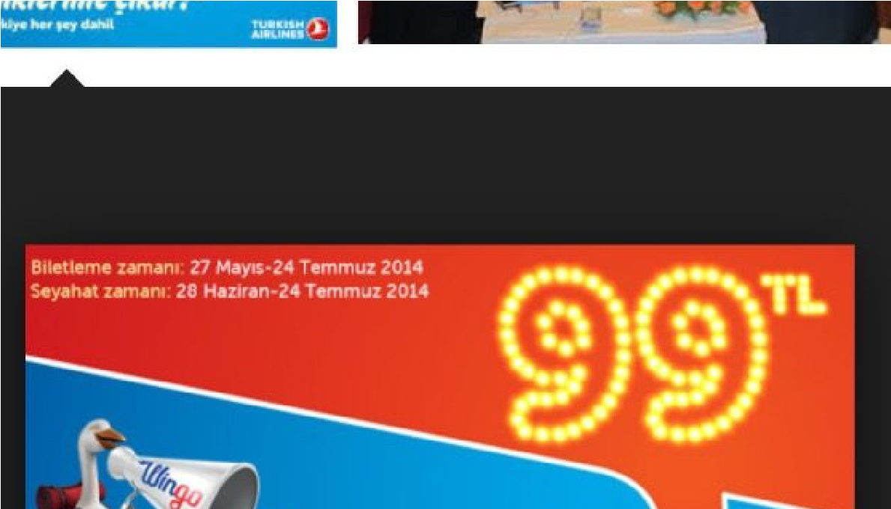Turkish Airlines also targets a local crow by following their tradition and moral.

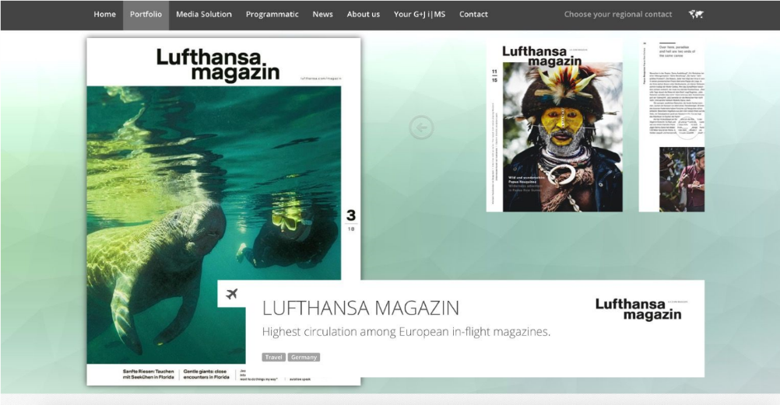**Magazines** are not the best way to promote your ads and brand because its a traditional media. Magazines do not sell as they used to now because of new media. Even though they are old media brands can benefit from this line of advertisement. Brands create a way to show their magazines in a way people will read.

## **Turkish Airlines**

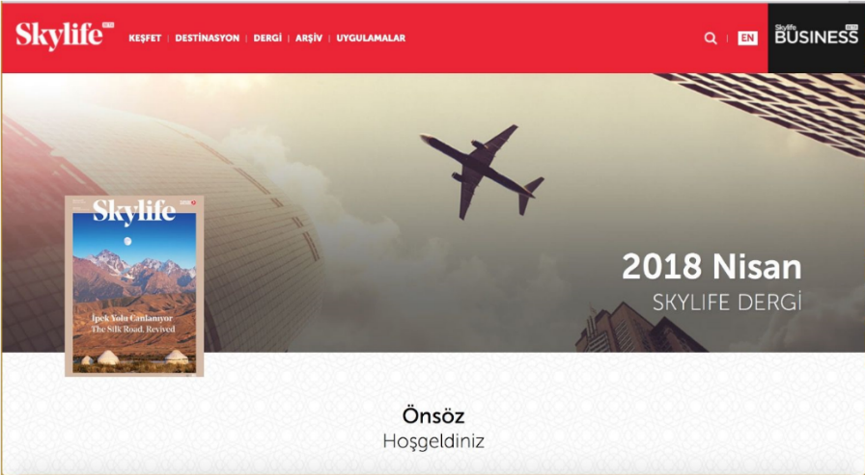

Turkish Airlines have their own magazine which shows place all around the Turkey and world for you to visit. They show you best places to see and eat.

## **Lufthansa**

Lufthansa takes a more serious and formal approach in their magazines. They have a better format in style which looks elegant and dedicated.

# Catalogue

Before and during the flight catalogs are used to inform passengers about what company does, how they work operate, what they offer and sell, their achievements. This is not an advertisement tool but rather an information platform.

## **Turkish Airlines**

In Turkish Airlines catalog reflect how globalized they are. Their catalog is more colorful and fun rather than blunt information.

## **Lufthansa**

Lufthansa takes a formal approach as usual. They have aesthetic which has simple colors.

# Store Design

Clever retail brands really understand the value of skillful store design and merchandising. Through extensive customer research they make sure they know their audience and plan their store design accordingly.

## **Turkish Airlines**

Turkish Airlines gives importance to all matters but especially, comforant of their customers. They usually use shooting colors like blue and grey. They try to create an environment which you will feel safe and sound.

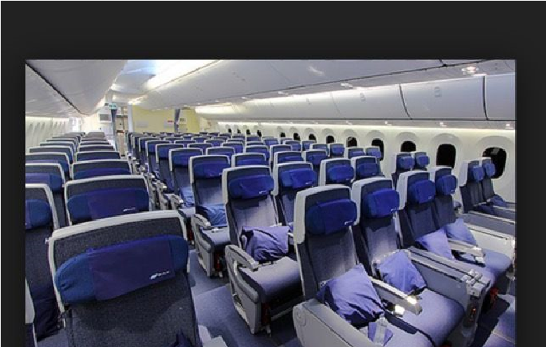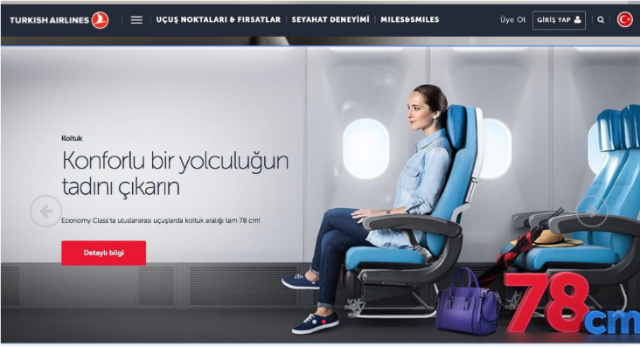

## **Lufthansa**

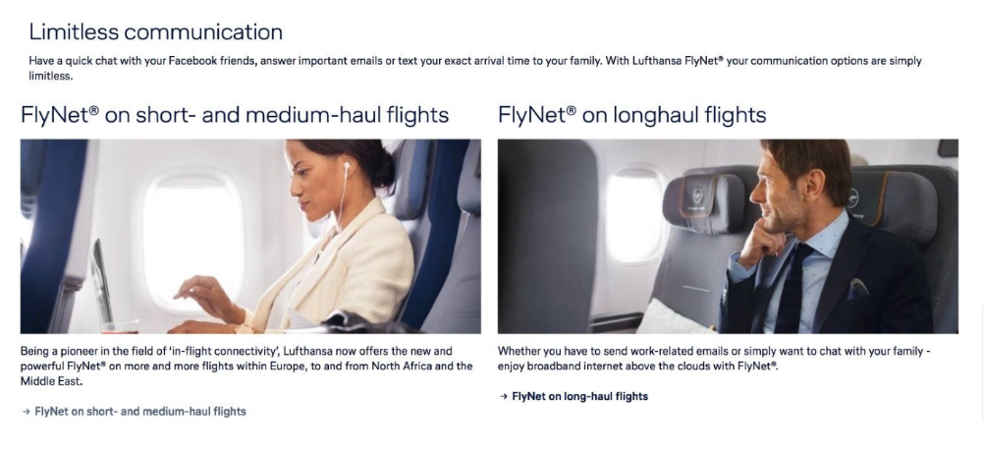Lufthansa creates an environment which feels luxurious and elegant. Their design is to create not only create comfort for their customers but also feel entertained. They also use blue.

# Brochures

Brochures allow brands to introduce new products and services to existing customers or increase their reach by advertising. They can be handed out in person, mailed, or left at specific lounges.

## **Turkish Airlines**

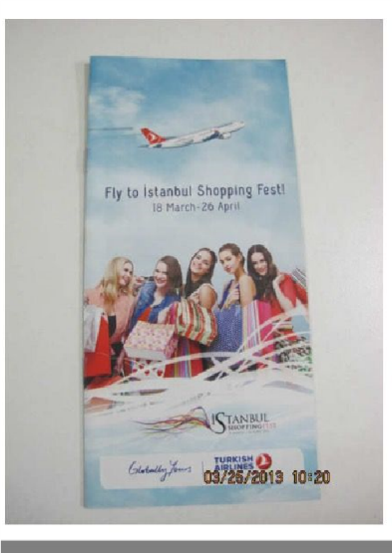Turkish Airlines gives brochures that shows deals and shows how family friendly their brand is.

## **Lufthansa**

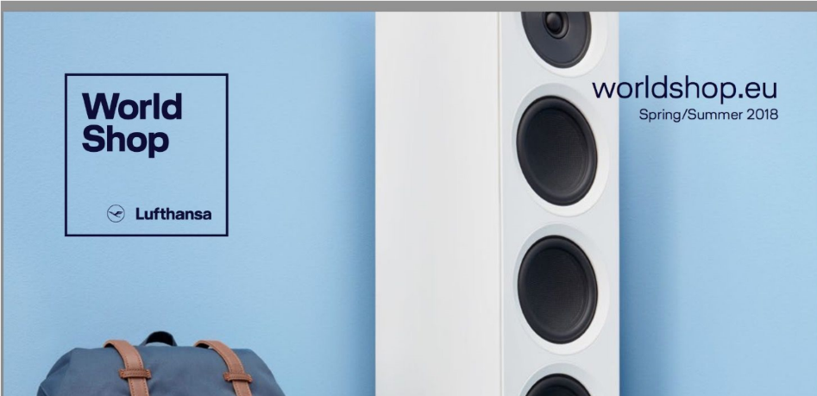Lufthansa does not take a very complicated and crowded approach. They give information in a very simple manner. Few texts straight to the point.

**Buzz Marketing**

One of the strategies of word of mouth. It aims to create a whisper around to make people curious and to attract more attention to the product when the product is revealed. There is no example of this marketing technique in Turkish Airlines and Lufthansa Airlines.

**Referral Programs**

To accelerate the diffusion of product or service satisfaction, it is the creation of tools that enable satisfied consumers to engage with their friends by recommending their experiences. 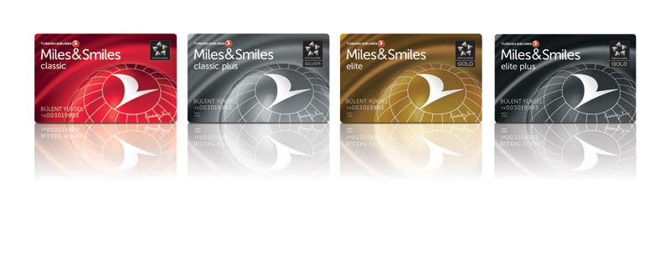

**Turkish Airlines**

Miles&Smiles: If you are a member of miles&smiles and if you invite your friends to become members, you can earn 500 bonus miles after your friends complete their first flight (THY, 2018).

**Guerilla Marketing**

It is a marketing technique that requires creativity, imagination, and fast mobility at its core. In unconventional environments, with unexpected methods, minimum marketing investments and maximum returns are the whole of marketing activities and strategies.

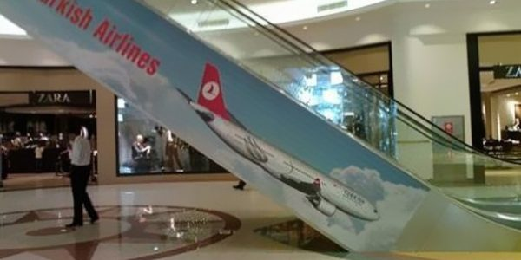

Turkish Airlines did guerilla marketing by using surrounding. This marketing technique aims that make people notice the advertisement in their daily life.

**Gamification**

Gamification is the process of adding entertainment and user comparisons by adding game fiction and graphics to ordinary games.

**Lufthansa**

**Miles&More:** Passengers with Miles & More credit cards will earn rewards in addition to any airfare they will buy. The award can be used to upgrade the national flight class, as well as for hotel accommodation coupons, concert tickets, events, or shopping (PartnerPlusBenefit, 2014).

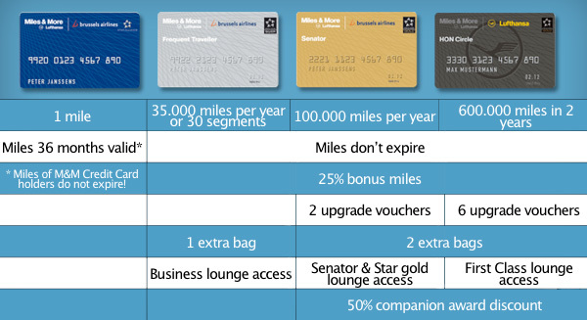

At the same time, a few status miles are added to the Miles & More account of a member on many Miles & More partner airlines operated flights. To qualify for membership status such as Frequent Traveler or Senator, the status is based on the national.

**Turkish Airlines**

Turkish Airlines transformed national flags into QR codes and placed them at digital bus stops to engage Olympic fans during the Olympics in London (Nigam S, 2012). Those who can scan these codes most with their mobile phone can buy tickets to one of the 200 destinations of Turkish Airlines.

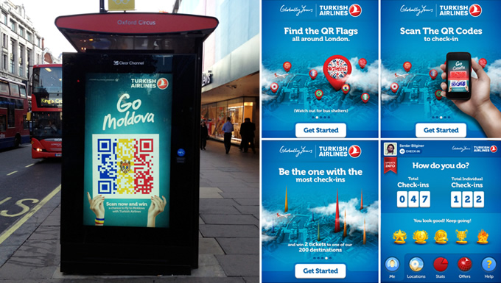

**Virtual Reality**

Virtual reality is a three-dimensional world created by computers. The items appear in a three-dimensional form, it is possible to move, see and hear. It provides a complete test facility for the user.

**Lufthansa**

In 2016, Lufthansa presented a VR experience for potential customers (Krau A, 2006). They sat the customers in a special chair and, gave customers a joystick.

Customers observed that they were sitting on the new LH Business Class chair, greeted them by their customers, even the hostesses, served food / drinks, and even the scenes, in the most realistic way.

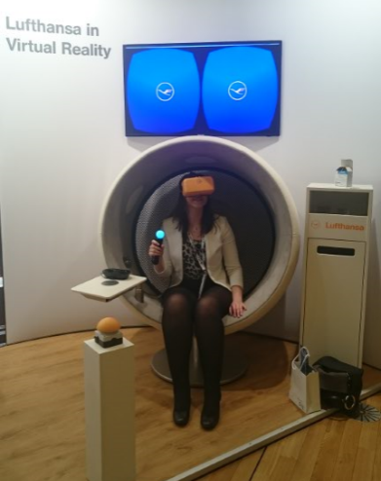

**Turkish Airlines**

Turkish Airlines offered a VR program for aviation enthusiast students, even though they did not have a VR program for the client. In 2014, the Turkish Airlines Aviation Academy took its place at IFTE, the aviation training fair (Turkish Aviation Academy, 2014). The wanderer to the booth experienced a fun flight experience, liking the flight with a digital technology-supported flight simulation to be used soon.

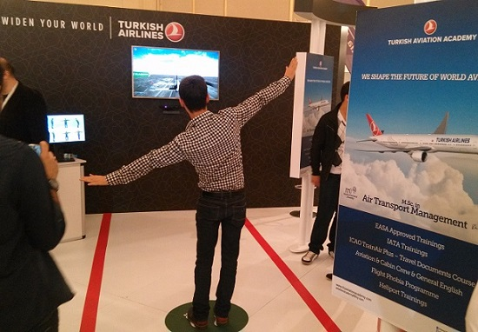

REPORT 8

**RFID Techonology**

**THY**

RFID (Radio Frequency Identification) basically is a technology that minimized the problems about baggage during travelling. Thy offers this technology to passengers who have Miles&Smile membership. If you are a member of Miles&Smiles, with a given 11-digit code, you can easily get in touch and solve your problem about your baggage (RFID Baggage Card, Thy, 2018).

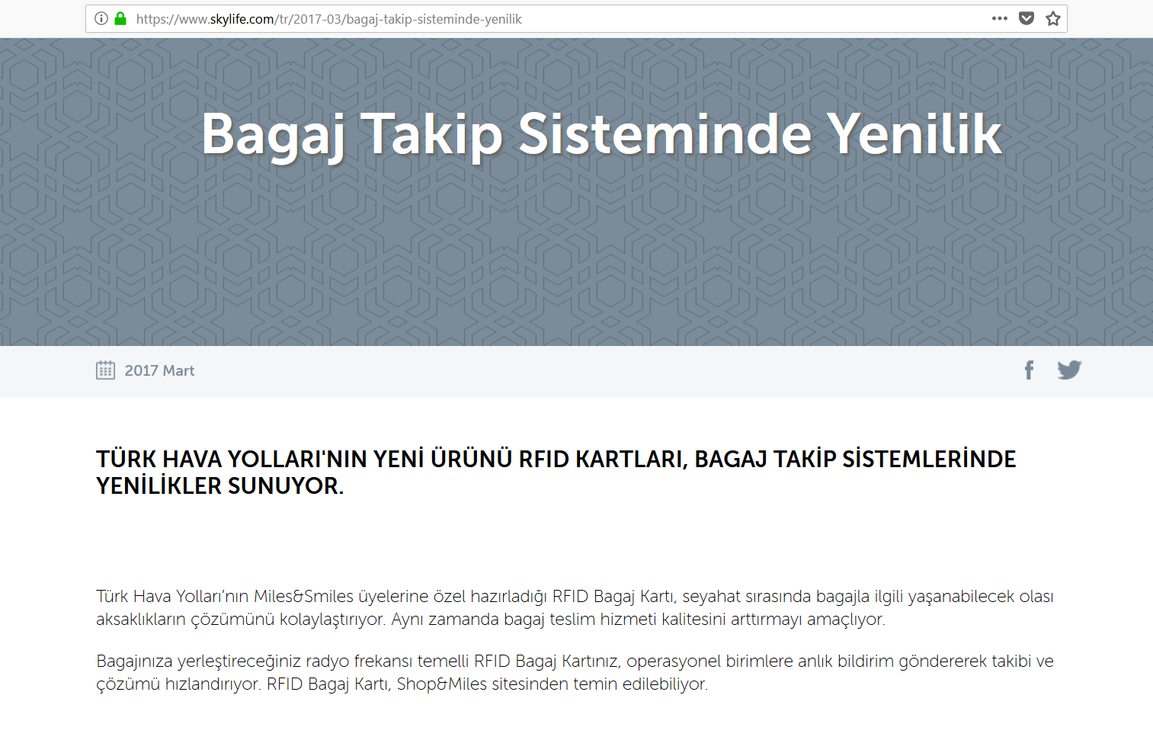There are some news on the internet about this new techlogical move by Thy. The following new shows that the technology also creates a good perception over the media. The Skylife uses “innovator” adjective for Thy which is good for “Word of Mouth” (Bagaj Takip Sisteminde Değişiklik, 2017, Sky Life).

**Lufthansa**

Like THY, also Lufthansa uses RFID Baggage Technology to improve baggage issues while travelling. Lufhansa have started to use RFID back in 2010. Also, they state that, use of the technology increases their efficiency during packaging by 70% and this yields increase in availability (RFID, Lufthansa, 2018). Compared to Thy, they have started earlier to use the RFID technology probably because they dont have just airplane company and also other companies in different sectors.

There are important news on media and it helps to the prestige of the company and “Word of Mouth”.

According to Ioxtra, Lufthansa have cooparted with BAGTAG to use RFID technology to minimize the issues related to baggage during flies (Ioxtra,2018).

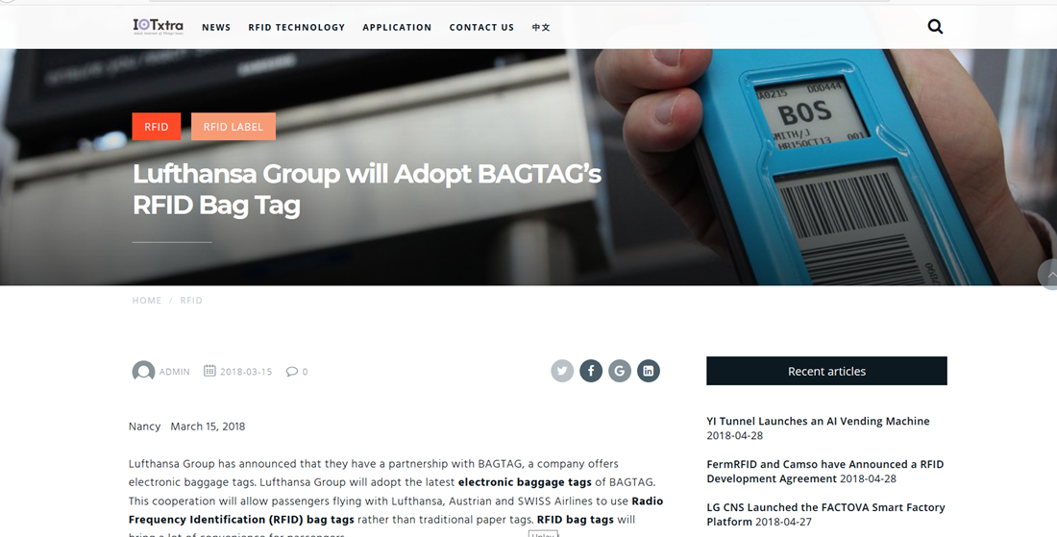

**Supply Chain**

Raw Materials

(Steel)

Service and Maintenance

Distribution Network

Manufacturers

(Engine,Aircraft)

Travel Agent

Airline

Passengers

**Reverse Logistics**

Reverse Logistics aims to reuse of products and materials. Re-use of products and materials is phenomenon in our daily lives too. If we give an example this may be paper recycling. It also helps to saving money and environmental resources. Nowadays, lots of companies make reverse logistics and they try to manage with the waste of materials they have.

**Turkish Airlines**

THY cares about the climate and environmental responsibility. For the sake of the environment THY makes fuel efficiency programs, uses alternative fuels and they have environmental and waste(disposal) management systems.

According to Environmental and Social Responsibility Report of Turkish Airlines, the Fuel Efficiency Program aimed at increasing fuel efficiency and reducing carbon emissions. Also, effectively managing fuel consumption contributes to profitability because fuel is the biggest cost item for an airline.

Also, THY has an environmental policy called the “Occupational Health and Safety Environment Policy”. This policy cares about the natural resources, emission measurements and wastes. They try to minimize them.

Furthermore, they have a separate way to handle with wastes. They use waste(disposal) management. There are types of wastes in airline system; contaminated packaging materials, hazardous wastes, nonhazardous wastes, electronic wastes and paper wastes. THY overcomes with these wastes by reporting them year to year and act according to their wastes.

**Lufthansa Airlines**

Lufthansa Group pays lots of attention to the environment.

According to Environmental Report: Recycling on Board(Vreden,2015), Lufthansa started a group-wide initiative called ‘Fly Greener’ to promote environmental awareness on board. In this project, crew members received a treatment about how to properly recycle during a flight. Then, with the help of the Lufthansa flight attendants, they separated waste items and the recyclable items. At the end, recycling on a board is a very beneficial action for the environment.

Not only the flight attendants help this recycling action but also the Lufthansa Technic Service makes a lot of effort to protect the environment and the resources. According to Resource Conservation, Lufthansa Technic sends their 60 percent of the wastes for recycling. In addition, they try to repair rather than throw away. They try to repair the parts of the aircraft as far as possible and by this way they treat their resources in a responsible way.

Also, Lufthansa Airlines have the environmental management which includes energy and resource management to make their energy and resources more economically, ecologically and efficiently.

**ATMOSPHERIC**

Atmospheric plays a big role in the design and performance of all the businesses in the world, because the place where the product is bought and consumed is ‘atmosphere’ (Krishna, Lwin & Morrin).

The atmosphere encompasses many items ranging from the design of stores to the store’s scent, even the song that plays there

Firms are very careful about the atmosphere, because the atmosphere is essentially unseen factors that connect the consumer to the brand.

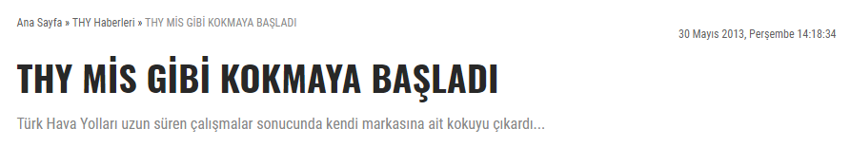

Turkish Airlines official Karahan said that 8 different kinds of smell were produced by bringing raw materials from 25 different countries during the work done since January 2012 and finally 2 smells were go on to the finals (2013). By conducting an evaluation survey, Turkish Airlines found its own smell. Customers commented on the scent as 'happiness, peace, refreshing smell'. The slogan that they put forward for their new smells they produce is 'now you can recognize us when your eyes closed'.

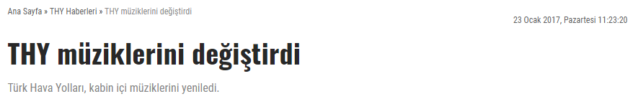

Turkish Airlines renewed its cabin music. Composer and arranger Mesut Kahramanoglu and clarinet artist Serkan Çağrı supervised the new music for departure and landing separately. While the landing music was 'Fresh', the name of the take-off music was 'Motif' (2017).

Turkish Airlines has focused on the brand music, and musics which are playing inside the planes. They realized that musics, which are playing inside the plane, have a big role in the mode of the consumer. Turkish Airlines created a soft music as landing music, and a active music as a take-off music.

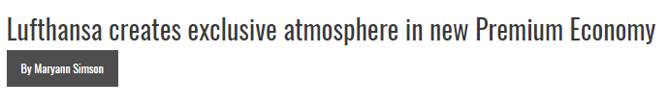

Lufthansa created a segment called premium-economy on his plane and made a few changes to the service within the plane and on the plane (2017).

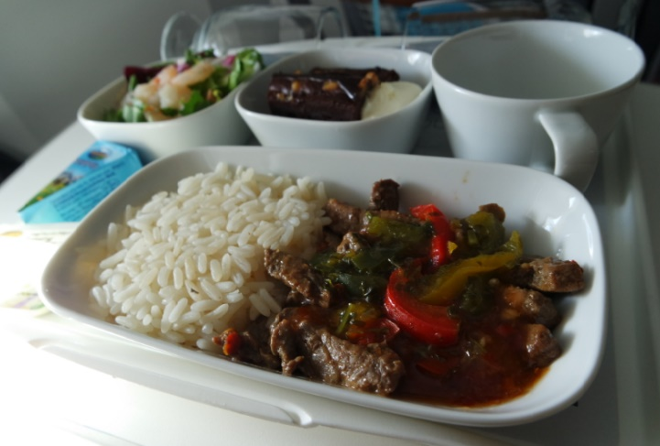

Lufthansa has granted access to the Lufthansa Business Class Lounge for an additional charge of $ 25 for its premium-economy ticket-issuing passengers. In the Business Class Lounge, a bottle of water was provided for each guest, plus the next meals were served with a napkin of real metal cutlery, porcelain plates and glass for drinks. At the end, he was pleased with the customers with the hot towel service.

REFERENCES

# Turkish Airlines Technic, TAI sign protocol to boost cooperation (2018, February 15). Retrieved from <http://www.hurriyetdailynews.com/turkish-airlines-technic-tai-sign-protocol-to-boost-cooperation-127393>

# Lufthansa redesigns logo, now in search of global PR agency (2018, February 9). Retrieved from <http://www.marketing-interactive.com/lufthansa-redesigns-logo-the-group-now-in-search-for-global-pr-agency/>

# Deutsche Lufthansa Aktiengesellschaft (LHA.DE) (2018, February 17). Retrieved from <https://finance.yahoo.com/quote/LHA.DE?p=LHA.DE>

# Türk Hava Yollari Anonim Ortakligi (THYAO.IS) (2018, February 17). Retrieved from <https://finance.yahoo.com/quote/THYAO.IS?p=THYAO.IS>

Deutsche Lufthansa Aktiengesellschaft (LHA.DE) (2018, February 17). Retrieved from<https://finance.yahoo.com/quote/LHA.DE/financials?p=LHA.DE>

Türk Hava Yollari Anonim Ortakligi (THYAO.IS) (2018, February 17). Retrieved from <https://finance.yahoo.com/quote/THYAO.IS/financials?p=THYAO.IS>

# Türk Hava Yolları 2015 Yıllık Rapor. (2015). Retrieved from <http://investor.turkishairlines.com/documents/THYInvestorRelations/yillik_raporlar/2015_yillik_rapor.PDF>

# Kişioğlu, E. (2014, December 8). Terörün Türk turizmine etkileri üzerine çözümler. Retrieved February 18,2018, from <https://indigodergisi.com/2014/12/terorun-turk-turizmine-etkileri-uzerine-cozumler/>

Karahan, G. (2015). Havayolu İşletmelerinde Yönetim Organizasyon Yapısı ve Stratejik Yönetim Uygulamaları, Türk Hava Yollarında Uygulanan Stratejik Yönetim Uygulamaları Üzerine Bir İnceleme (Unpublished master’s thesis). Türk Hava Kurumu Üniversitesi. Retrieved February 18,2018, from <https://tez.yok.gov.tr/UlusalTezMerkezi/TezGoster?key=Br_XTptK8CZ70f0JGX9xEtJqbS9gS7icsvahLOQb2JYEXG_q00zuZ7oeTRhVw6xf>

Bhasin, H. (2017, December 17). SWOT Analysis of Lufthansa Airlines. Retrieved February 18, 2018, from [https:/www.marketing91.com/swot-analysis-lufthansa-airlines/](https://www.marketing91.com/swot-analysis-lufthansa-airlines/)

BBC (Ed.). (2012, September 6). Lufthansa Grevi Başladı. Retrieved February 18, 2018, from <http://www.bbc.com/turkce/haberler/2012/09/120906_luftansa_strike>

Milliyet (Ed.). (2012, September 7). Luftansa Grevi Seferleri Aksattı. Retrieved February 18, 2018, from <http://www.milliyet.com.tr/Milliyet-Tv/nevidyo/video-izle/Lufthansa-grevi-seferleri-aksatti-1L3TvB688BD8.html>

Eyüboğlu, K & Eyüboğlu, S. (2016, June). Brent Petrol Fiyatının Havayolu Şirketlerinin Hisse Senedi Fiyatlarına Etkisi. *Çukurova Üniversitesi İİBF Dergisi, 20*(1), *39-53.* Retrieved February 18, 2018, from <http://iibfdergi.cu.edu.tr/2016/ozet_4_eyuboglu_2016_1.pdf>

İstanbul – Miami Hattındaki Yolcu Sayısı Yüzde 65 Arttı (2018,February,12) Retrieved from <http://www.oncevatan.com.tr/roportaj/istanbul-miami-hattindaki-yolcu-sayisi-yuzde-65-artti-h120696.html>

Turkish Airlines Growth Strategy: Success or Failure? (2011,September,4) Retrieved from <http://www.frost.com/c/10036/blog/blog-display.do?id=386733>

Group Strategy (2016) Retrieved from [https://investor-relations.lufthansagroup.com/en/fakten-zum-unternehmen/group-strategy.html#a-top](https://investor-relations.lufthansagroup.com/en/fakten-zum-unternehmen/group-strategy.html" \l "a-top)

Lufthansa Group with New Holiday Destinations (2015) Retrieved from <https://www.lufthansa.com/mediapool/pdf/55/media_366939655.pdf>

Sosyal Sorumluluk Projelerimiz (THY, 2018). Retrieved from <https://www.turkishairlines.com/tr-tr/basin-odasi/sosyal-sorumluluk-projelerimiz/>

Social Responsibility (Lufthansa, 2018). Retrieved from <https://www.lufthansagroup.com/en/responsibility/social-responsibility.html>

Kurumsal Iletisim. (THY, 2018). Retrieved from <http://investor.turkishairlines.com/documents/ThyInvestorRelations/download/THY2015TR/kurumsaliletisim.html>

THY'den Japonya'da sosyal sorumluluk projesi (THY, 2018). Retrieved from <http://aa.com.tr/tr/dunya/thyden-japonyada-sosyal-sorumluluk-projesi/456499>

Impact of a Wish: WestJet & Make-A-Wish Canada (2017) Retrieved From <http://engageforgood.com/halo-award/impact-wish/>

Memnuniyet listesinde THY zirvede (2016) Retrieved From [www.haberturk.com/ekonomi/is-yasam/haber/1338623-memnuniyet-listesinde-tyh-zirvede](http://www.haberturk.com/ekonomi/is-yasam/haber/1338623-memnuniyet-listesinde-tyh-zirvede)

Sample Size Calculator (Survey System, 2018). Retrieved From <https://www.surveysystem.com/sscalc.htm>

Business Demography Statistics (Euro-stats, 2017). Retrieved From <http://ec.europa.eu/eurostat/statistics-explained/index.php/Business_demography_statistics>

What is Amazon Smile? (Bloom Worldwide, 2017).Retrieved From <http://www.bloomworldwide.org/amazon-associates-vs-amazon-smiles/>

the Experiential Buying Tendency Scale (Beyond the Purchase, 2018). Retrieved From <http://www.beyondthepurchase.org/explore.php>

Widen Your World (THY, 2018). Retrieved From <https://www.turkishairlines.com/en-ae/flights/>

This map shows where women outnumber men around the World. (Business Insider, 2015) Retrieved From <http://www.businessinsider.com/map-showing-ratio-of-women-and-men-2015-8>

Widen Your World. (THY,2018) Retrieved From <https://www.turkishairlines.com/en-us/flights/index.html>

New Marketing Trend: Meet The “Manfluencers”. (Newser,2013) Retrieved From <https://www.usatoday.com/story/news/nation/2013/10/27/newser-marketing-men/3280773/>

Marketing to Men by Appealing to “Manfluencers” (Abel,2013). Retrieved From <https://www.consumeraffairs.com/news/marketing-to-men-by-appealing-to-manfluencers-102513.html>

Marketing Strategies of Lamborghini (Azeel,2016). Retrieved From <https://www.slideshare.net/aseelm1/marketing-strategies-of-lamborghini>

Picture of Lamborghini. Retrieved From (2018) <https://www.carscoops.com/wp-content/uploads/2017/05/aventador-miura.jpg>

Niche Marketing Nedir? (Ozan,2010). Retrieved From <https://ozanguzelkan.wordpress.com/2010/06/10/niche-marketing-nedir-nis-pazarlama-focused-marketing-kucuk-sirketler-degisik-fikirler-piyasa-pazar-buyuk-sirketler-nis-urunler-hedef-kitle-market-stratejisi-nis-pazarlama-nedir-mass-marketing-nedir/>

Targeting Solutions for Niche Market Challenges (Clarkson University,2014). Retrieved From <https://www.sciencedaily.com/releases/2014/05/140516202701.htm>

15 Product Trademarks That Have Become Victims of Genericization (Consumerist,2017). Retrieved from <https://consumerist.com/2014/07/19/15-product-trademarks-that-have-become-victims-of-genericization/>

Wikizero (2018). Retrieved from <https://www.wikizero.com/>

Genericide: Brands Destroyed by Their Own Success (BBC, 2014). Retrieved from <http://www.bbc.com/news/business-27026704>

Widen Your World (THY 2018). Retrieved from <https://www.youtube.com/watch?v=yvicqMrAHvQ>

Widen Your World (THY,2018). Retrieved from [https://www.turkishairlines.com/en-us/flights/#tcm40-10300](https://www.turkishairlines.com/en-us/flights/" \l "tcm40-10300)

Lufthansa Cargo (Lufthansa,2018). Retrieved from <https://lufthansa-cargo.com/home>

What is Consumer Profile? (Geekinterview 2008). Retrieved from <http://www.learn.geekinterview.com/data-warehouse/dw-basics/what-is-consumer-profile.html>

Consumer Profile Defining the Ideal Customer (the Balance, 2018). Retrieved from <https://www.thebalance.com/consumer-profile-defining-the-ideal-customer-2296932>

What is Dynamic Pricing (Ecommercewiki, No-Date). Retrieved from <https://www.ecommercewiki.org/Dynamic_Pricing/Dynamic_Pricing_Basic/What_is_Dynamic_Pricing>

(THY, 2018). Retrieved from <https://www.turkishairlines.com/>

(Enuygun, 2018). Retrieved from <https://www.enuygun.com>

(Momondo, 2018). Retrieved from <https://www.momondo.com.tr>

Online Uçak Bileti. (Online Uçak Bileti, 2018) Retrieved From <https://www.online-ucak-bileti.com/ucakbileti/Sefer.aspx?ysOgrenci=0&ysYetiskin=1&ysYasli=0&ysCocuk=0&ysBebek=0&gdOriginCode=IST&gdDestinationCode=ADB&gTarih=11/04/2018&dTarih=&ucusTipi=OW&flightClass=Economy&NeredenTumu=true&NereyeTumu=true>

Hepsiburada. (Hepsiburada,2018) Retrieved From <https://www.hepsiburada.com/prima-bebek-bezi-premium-care-5-beden-junior-aylik-firsat-paketi-136-adet-p-HBV000005KOLD>

N11. (N11, 2018) Retrieved From <https://urun.n11.com/sony-playstation-4/sony-ps4-slim-500gb-3-oyun-3-aylik-psn-gow-u4-hzd-P241010410?cid=604001&gclid=CjwKCAjwwbHWBRBWEiwAMIV7E_BnR3fgQhWkLXsAgU7LcuTgJ7DZvj89JaHX1zSbHbkS5MjmKypeHhoCB88QAvD_BwE&gclsrc=aw.ds>

Environmental and Social Responsibility (THY, No-Date) Retrieved From <http://investor.turkishairlines.com/documents/ThyInvestorRelations/download/icerikler/environmental_and_social_responsiblty.pdf>

Cooperate Responsibility (Lufthansa, 2018) Retrieved From <https://www.lufthansagroup.com/en/responsibility/corporate-responsibility.html>

Cooperate Club (THY, 2018) Retrieved From

<https://p-tcc.turkishairlines.com/en-gb/blog/>

Golf Events (THY, 2018) Retrieved From

<http://golf.turkishairlines.com/turkish-airlines-world-golf-cup/events/>

Your Applications Events (Lufthansa, 2018) Retrieved From

<https://www.be-lufthansa.com/en/about-your-application/events/>

Meetings and Events (Lufthansa, 2018) Retrieved From

<https://www.lufthansa.com/us/en/Meetings-and-Events-Delegates>

THY’nin sponsor olduğu turnuvalar (Biletall, 2016) Retrieved From

<https://www.biletall.com/blog/turk-hava-yollarinin-sponsor-oldugu-turnuvalar/>

THY’den dev sponsorluk anlaşması (A Haber, 2016) Retrieved From

<https://www.ahaber.com.tr/galeri/turkiye/thyden-dev-sponsorluk-anlasmasi/2>

THY şampiyonlar ligine sponsor oldu(Fanatik, 2015) Retrieved From

<http://www.fanatik.com.tr/2015/03/24/turk-hava-yollari-thy-sampiyonlar-ligine-sponsor-oldu-419464>

Business economy (Arab News, 2018) Retrieved From

<http://www.arabnews.com/node/1250586/business-economy>

Lufthansa continues as Germanys Olympic Airline (Sports Pro Media, 2013) Retrieved From

<http://www.sportspromedia.com/news/lufthansa_continues_as_germanys_olympic_airline>

Batman vs Superman THY product placement (Market Wired, 2016) Retrieved From

<http://www.marketwired.com/press-release/batman-v-superman-turkish-airlines-product-placement-by-a-list-entertainment-inc-2111282.htm>

Batman vs Superman THY product placement (Market Wired, 2016) Retrieved From

<http://www.marketwired.com/press-release/batman-v-superman-turkish-airlines-product-placement-by-a-list-entertainment-inc-2111282.htm>

Lufthansa airline hologram (Product Placement Blog, 2018) Retrieved From

<https://productplacementblog.com/movies/lufthansa-airline-hologram-in-anon-2018/>

Press (Lufthansa Group, 2018) Retrieved From

<https://www.lufthansagroup.com/en/press.html>

Lufthansa mail charts (Mail Charts, 2015) Retrieved From

<https://www.mailcharts.com/companies/1686/lufthansa>

THY New Advertisement (Dailymotion, 2018) Retrieved From

http://www.dailymotion.com/video/x1r27pa

Everybody is Lufthansa (YouTube, 2018) Retrieved From

<https://www.youtube.com/watch?v=FD9UTBWo51w>

Miles and Smiles (Sesizi, 2018) Retrieved From

<http://www.sesizi.com/thy-miles-smiles/>

Award 7 (Radio Advertisement, 2018) Retrieved From

<https://www.radio-advertising-award.de/#award/7>

Lufthansa Billboard (Google, 2018) Retrieved From

https://www.google.com/search?q=lufthansa+billboard&client=safari&rls=en&tbm=isch& tbo=u&source=univ&sa=X&ved=0ahUKEwiV8sPj7eHaAhWiYpoKHSyEAMUQsAQIMQ&bi w=1240&bih=649&dpr=2

THY Billboard (Google, 2018) Retrieved From

https://www.google.com/search?q=turk+hava+yollar%C4%B1+billboard&client=safari&rl s=en&tbm=isch&tbo=u&source=univ&sa=X&ved=0ahUKEwiEmPyg9eHaAhXkdpoKHTUD CpUQsAQIMg&biw=1240&bih=649

Review THY business class (the Filipinotravelersblog, 2016) Retrieved From

https://thefilipinotravelersblog.blogspot.com.tr/2016/11/review-turkish-airlines-businessclass.html

Review THY business class (World Shop, 2016) Retrieved From

<https://www.worldshop.eu/en/page/catalogue-viewer?p=jP1XHwhpcLE>

THY brosur (Gittigidiyor, 2018) Retrieved From

<https://urun.gittigidiyor.com/koleksiyon/turk-hava-yollari-brosur-103216543>

Mil Kazanma (PPB, 2018) Retrieved From

[**https://www.ppb-infolounge.com/tr-GR/mil-kazanma/**](https://www.ppb-infolounge.com/tr-GR/mil-kazanma/)

Miles and Smiles (THY, 2018) Retrieved From

[**https://www.turkishairlines.com/tr-sa/miles-and-smiles/**](https://www.turkishairlines.com/tr-sa/miles-and-smiles/)

Miles and Smiles (Akedemi THY, 2014) Retrieved From

[**https://akademi.thy.com/newsdetail/turk-hava-yollari-havacilik-akademisi-ifte-2014-havacilik-egitim-fuarinda-oldukca-ilgi-gordu/6**](https://akademi.thy.com/newsdetail/turk-hava-yollari-havacilik-akademisi-ifte-2014-havacilik-egitim-fuarinda-oldukca-ilgi-gordu/6)

Virtual reality, what potential for travel industry (Travel Think, 2016) Retrieved From

[**http://www.travel-think.com/virtual-reality-what-potential-for-the-travel-industry/**](http://www.travel-think.com/virtual-reality-what-potential-for-the-travel-industry/)

Gamification Dynamics (Medium, 2014) Retrieved From

[**https://medium.com/yalantis-mobile/gamification-dynamics-in-user-experience-543c8bb32898**](https://medium.com/yalantis-mobile/gamification-dynamics-in-user-experience-543c8bb32898)

100 Yaratici gerilla marketing örneği (Pazarlamasyon, 2013) Retrieved From

[**http://www.pazarlamasyon.com/pazarlama/gerilla-pazarlama/100-yaratici-gerilla-marketing-ornegi/**](http://www.pazarlamasyon.com/pazarlama/gerilla-pazarlama/100-yaratici-gerilla-marketing-ornegi/)

Gamification (Airline Trends, 2016) Retrieved From

[**http://www.airlinetrends.com/tag/gamification/**](http://www.airlinetrends.com/tag/gamification/)

Bagaj Sisteminde Yenilik (Sky Life,2017). Retrieved from <https://www.skylife.com/tr/2017-03/bagaj-takip-sisteminde-yenilik>

RFID (THY,2018). Retrieved from <https://www.turkishairlines.com/en-at/any-questions/rfid/index.html>

RFID (Lufthansa,2018). Retrieved from <https://www.lufthansa-technik.com/home?p_p_id=101&p_p_lifecycle=0&p_p_state=maximized&p_p_mode=view&_101_struts_action=%2Fasset_publisher%2Fview_content&_101_returnToFullPageURL=https%3A%2F%2Fwww.lufthansa-technik.com%2Fhome%3Fp_auth%3DoMHimWt1%26p_p_id%3D3%26p_p_lifecycle%3D1%26p_p_state%3Dnormal%26p_p_state_rcv%3D1&_101_assetEntryId=196303&_101_type=content&_101_urlTitle=article-rfid-media-relations&inheritRedirect=true>

Lufthansa Group will adopt bag tags (Ioxtra,2018). Retrieved from <http://www.iotxtra.com/lufthansa-group-will-adopt-bagtags-rfid-bag-tag/>

Win-win recycling on board (lsgskycehfs,2015). Retrieved from <https://blog.lsgskychefs.com/environment/win-win-recycling-on-board/>

Resource Conservation (Lufthansa,2018). Retrieved from

<https://www.lufthansa-technik.com/resource-conservation>

Climate and Environmental Responsibility (Lufthansa,2018). Retrieved from

<https://www.lufthansagroup.com/en/responsibility/climate-and-environmental-responsibility/energy-and-resource-management.html>

Krishna, A., Lwin, M. O., & Morrin, M. (n.d.). Product Scent and Memory. *JOURNAL OF CONSUMER RESEARCH,*57-66. Retrieved May 6, from https://pdfs.semanticscholar.org/3a8c/c5a202b1d9ed40006c70de9b34cb2fd49afc.pdf.

THY MİS GİBİ KOKMAYA BAŞLADI. (2013, May 30). Retrieved May 6, 2018, from <http://www.airporthaber.com/thy-haberleri/thy-mis-gibi-kokmaya-basladi.html>

THY müziklerini değiştirdi. (2017, January 23). Retrieved May 6, 2018, from <http://www.airporthaber.com/thy-haberleri/thy-muziklerini-degistirdi.html>

Lufthansa creates exclusive atmosphere in new Premium Economy - Runway Girl. (2017, October 18). Retrieved from https://runwaygirlnetwork.com/2014/10/10/lufthansa-creates-exclusive-atmosphere-in-new-premium-economy/